Age 11+ Level
Worksheet 4

- Birthday Tables
Mark has lots of tables in his (large) house. Each circular table will seat 5 people and each rectangular table will seat 8 people.
At his birthday party there will be 36 people, including himself. Mark wants there to be no empty seats at any of the tables that are used.
How many tables of each type does Mark need to use in order to achieve this? Is this the only possibility?
- Currency Exchange
Dan has nine 20p coins and his sister Ann has eight 50p coins.
What is the smallest number of coins that must change hands so that Dan and Ann end up with equal amounts of money?
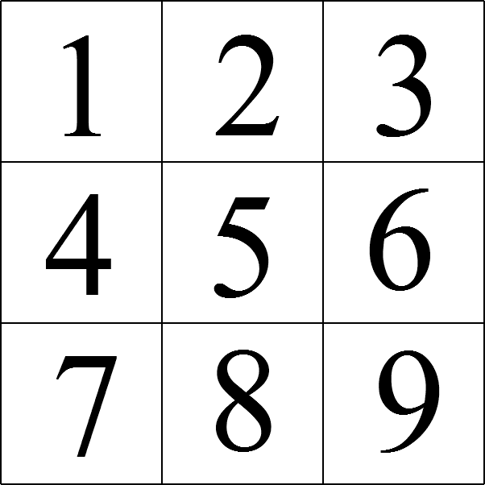
- Latin Multiplication
I choose three numbers from this number square, including one number from each row and one number from each column. I then multiply the three numbers together.

What is the largest possible product?

- Product and Sum
Jim rolled some dice and was surprised that the sum of the scores on the dice was equal to the product of the scores on the dice.
One of the dice showed a score of 2, one showed 3 and one showed 5. The rest showed a score of 1.

How many dice did Jim roll?

4 | 5 | 7 | 14
6 | 13 | 3
11 | 12 | 9
10
- Anti-magic Square
A 4 by 4 "anti-magic square" is an arrangement of
the numbers 1 to 16 in a square, so that the totals of each of the four rows and four columns and two main diagonals are ten consecutive numbers in some order.
The diagram shows an incomplete anti-magic square. Can you fill in the missing numbers
(1, 2, 8, 15 and 16) to complete it?

