A/Splitting vertically
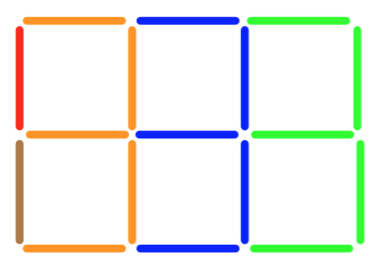 A split up in groups from the right gives: 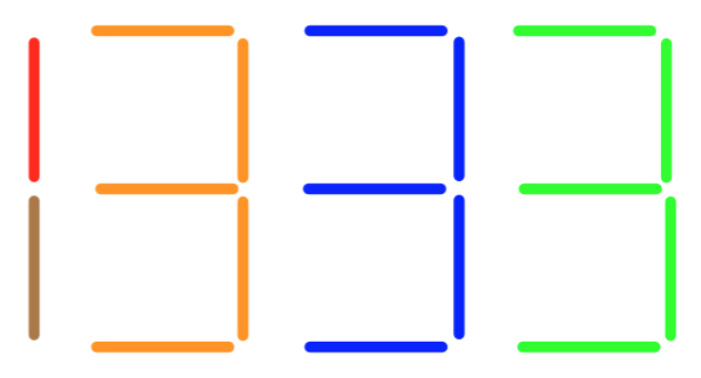
which can be seen as 1+1+5+5+5 = 17 More: 1+1+1+7+7+7+7=31; (see 10 in summary)

B/Splitting horizontally
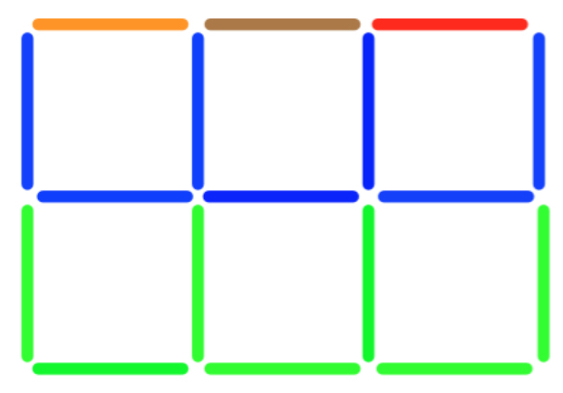 This time split up in groups from the bottom gives: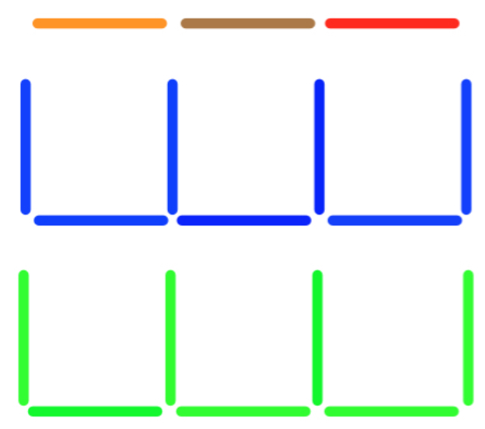
Can be seen as 1+1+1+7+7 = 17 More: 1+1+1+1+9+9+9=31 (see 9 in summary)

C/Using sloping lines:
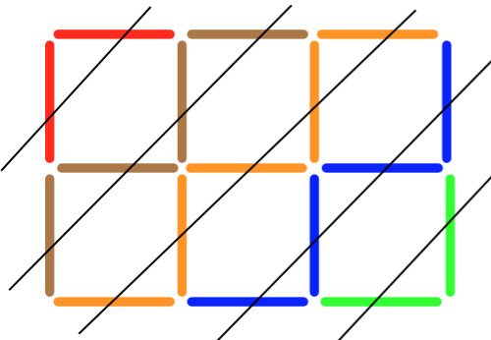Green = 2; blue = 4; orange = 5; brown = 4; red = 2 added makes 17
Can be seen as 2+4+5+4+2 = 17 More:2+4+6+7+6+4+2=31; 2+4+6+8+9+8+6+4+2 =49
Or 2x6+5=17; 2x12+7=31; 2x20+9=49 (see 3 in summary)

D/Counting outside/inside:

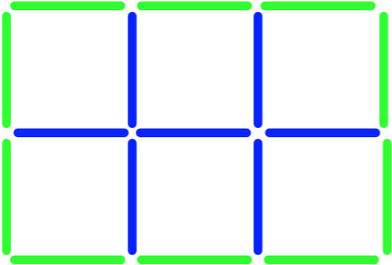 Round the outside in green gives 10; inside in blue gives 7 making 17
Can be seen as 10 + 7 = 17 More: 14 + 17 = 31; 18 + 31 = 49
Rearrange
6 + 1 = 7
10 + 7 = 17
14 + 17 = 31
18 + 31 = 49
Etc. (see 8 in summary)

E/Using multiplication facts
6 x 1 + 1 = 7
6 x 3 – 1 = 17
6 x 5 + 1 = 31
6 x 8 + 1 = 49
Etc. pattern goes +1 -1 +1 +1 -1 +1

F/
First is a 1 by 2 and the second is a 2 by 3, times the two 2’s together and the 1&3 = 4 + 3=7
Next a 2 by 3 and then the 3 by 4, times the two 3’s together and the 2&4 = 9 + 8 = 17
Again 3 by 4 and then the 4 by 5, times the two 4’s together and the 3&5 = 16 + 15 = 31
EG for 2 by 3 (see 5 in the summary)
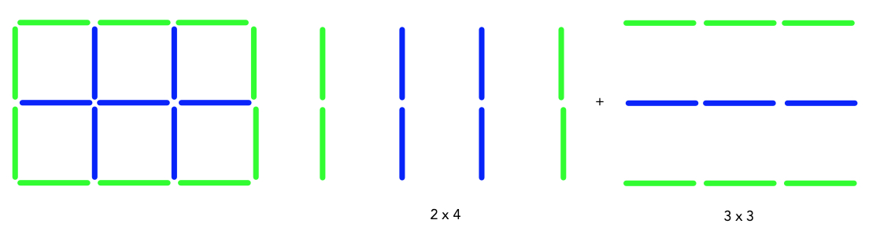
G/
Using area to show the numbers in the pattern

1 by 2 gave 7 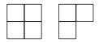 so 2 x 2² -1

2 by 3 gave 17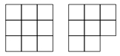 so 2 x 3² -1

3 by 4 gave 31 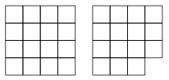 so 2 x 4² -1

4 by 5 gave 49 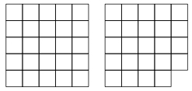 so 2 x 5² -1 (see 6 in the summary)

H/
Using the notation that T1 and T2 means 1st and 2nd Triangular numbers repectively etc.

1 by 2 = 2 + (T1 x 5) = 7 (T2 x 2) + (1 x 1) + 1 -1 (T1 x 4) + 1 + 2
2 by 3 = 2 + (T2 x 5) = 17 (T3 x 2) + (2 x 2) + 2 -1 (T2 x 4) + 2 + 3
3 by 4 = 2 + (T3 x 5) – T1 = 31 (T4 x 2) + (3 x 3) + 3 -1 (T3 x 4) + 3 + 4
4 by 5 = 2 + (T4 x 5) – T2 = 49 (T5 x 2) + (4 x 4) + 4 -1 (T4 x 4) + 4 + 5
5 by 6 = 2 + (T5 x 5) – T3 = 71 (T6 x 2) + (5 x 5) + 5 -1 (T5 x 4) + 5 + 6
Etc.

I/ Twice area + length + height

1 by 2 = 2 (1x2) + 1+2 =7
2 by 3 = 2 (2x3) + 2+3 =17
3 by 4 = 2 (3x4) + 3+4 =31
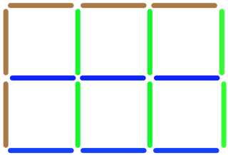 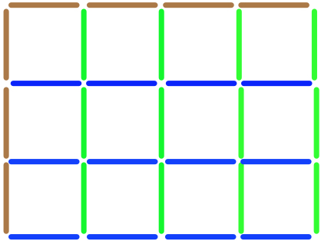 Area is length x height which is shown as blues and greens.
Length plus height is shown in brown. (See 3 in summary)
J/
Starting with a 3 by 3 square using 24 edges, add a kind of 3 using 7 edges to make the 3 by 4 window using 31 edges | 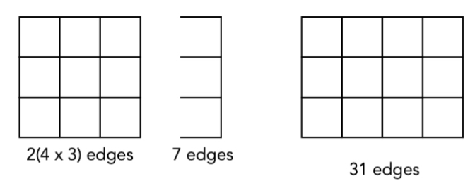
Starting with a 4 by 4 square using 40 edges, remove a series of “U’s” that uses 9 edges to make the 3 by 4 window using 31 edges | 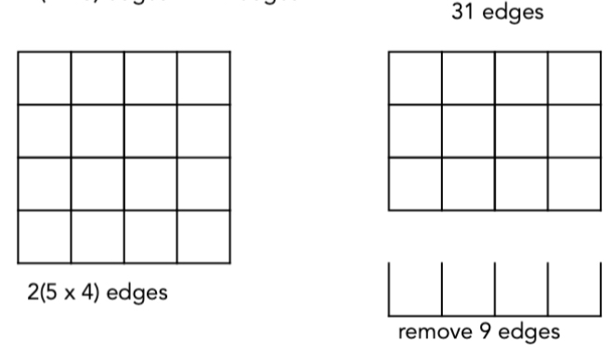

To make a m by m square uses 2(m x n) edges; the extra to add on is m + n so altogether 2(m x n) + m + n (see 3 in summary)
To make the larger n by n square uses 2(n x (n+1)) edges; the extra that needs removing is (n + (n+1)) so altogether 2(n x (n + 1))-(n + n + 1) i.e. 2n² - 1 (see 6 in summary)

K/
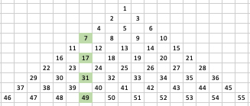
Showing 7, 7+10, 17+14, 31+18, 49+22
1by2 7
2by3 7+10
3by4 17+14
4by5 31+18
m by n = 7 + 2(m.n – n + 2m -2) (see 11 in summary)

L/
Now we have the number being made up of the frame and the total for the previous size.
For example the 2 by 3 is 10 + 7 = 17; the 3 by 4 is made up of 14 + [10 + 7] i.e. 14+17
We calculate the 3 by 4 by adding all the frames going back to the 1 by 2 and then add 1.
Because the frame is twice the length + height.
So again the 3 by 4 is 2(3+4 add 2+3 add 1+2) + 1

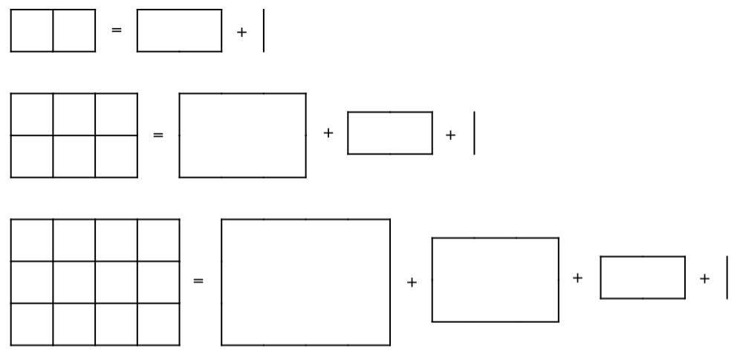

IN SUMMARY
With n = m+1
1/ m by n m + n(2n-1)
2/ m by n n + m(2n+1)
3/ m by n 2(m x n) + (m + n)
4/ m by n 2(m+n) + 2m² -1
5/ m by n m(n+1) + (n x n)
6/ m by n 2(n x n) - 1
7/ m by n 5((m x n)/2) - ((m-2) x (n-2)/2) + 2
8/ m by n 6+ (m-1)4 + 2(m x m) – 1 or 4(m-1) + 2(m x m) + 5
9/ m by n n + m² + mn + 2m
10/ m by n m + mn + n²
11/ m by n 7 + 2(m.n – n + 2m - 2)

