My solution: Magic Crosses
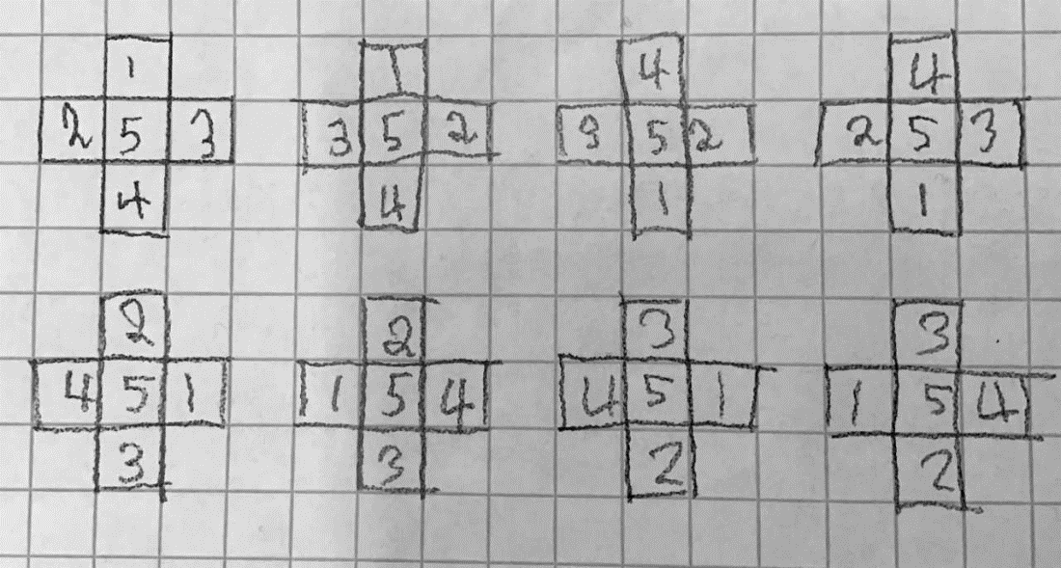
1
2
3
4
5
6
7
8
There are eight ways to do it with one number in the middle. Even numbers can’t go in the middle because there will only be one even number and three odd numbers.
Odd + even = odd
Odd + odd = even
I did this with all the numbers, and I figured out that one, three and five were the only possible numbers in the middle and there were three of them. I then figured out that that two and four were not possible because of the even reason. I figured out that 3 x 8=24 and that there were 24 ways.

2,3,4,5,6
There are eight ways to do it with one number in the middle. Odd numbers can’t go in the middle because there will only be one odd number and three even numbers.
Odd + even = odd
Even + even = even
I did this with all the numbers, and I figured out that two, four and six were the only possible numbers in the middle and there were three of them. I then figured out that that three and five were not possible because of the odd reason. I figured out that 3*8=24 and that there were 24 ways.
3,4,5,6,7
There are eight ways to do it with one number in the middle. Even numbers can’t go in the middle because there will only be one even number and three odd numbers.
Odd + even = odd
Odd + odd = even
I did this with all the numbers, and I figured out that three, five and seven were the only possible numbers in the middle and there were three of them. I then figured out that that four and six were not possible because of the even reason. I figured out that 3*8=24 and that there were 24 ways.
98,99,100,101,102
There are eight ways to do it with one number in the middle. Odd numbers can’t go in the middle because there will only be one odd number and three even numbers.
Odd + even = odd
Even + even = even
I did this with all the numbers, and I figured out that 98, 100 and 102 were the only possible numbers in the middle and there were three of them. I then figured out that that 99 and 101 were not possible because of the odd reason. I figured out that 3*8=24 and that there were 24 ways.
All the ways with 50 in the middle
All the magic cross numbers with 50 in them are:
46,47,48,49,50/47,48,49,50,51/48,49,50,51,52/49,50,51,52,53/50,51,52,53,54
The only ones that can have 50 in the middle are:
46,47,48,49,50/48,49,50,51,52/50,51,51,53,54
...because then when fifty is in the middle there will be two odds and two evens which we need. Since there are 3 ones possible with 50 in the middle and there is eight ways for each magic cross there are 24 magic crosses with 50 in the middle.
If the numbers went up in 2’s
If the numbers were 2,4,6,8,10 then you would only be able to put 2,6 and 10 in the middle because you can’t add up 2 pairs to make the same number with 2,6,8,10 or 2,4,6,10. There are 24 crosses if the numbers went in 2’s.
If the numbers went up in 10’s and 100’s
For this solution I realized I could use my first solution because you could just times 1,2,3,4,5 by 10 and 100 and you would get the same number of magic crosses. This led to me to the solution of 24, so if the numbers went up in 10’s and 100’s the answer would be the same.
If the numbers went up in 20’s
This solution will be the same if they went up in 2’s but, you times it by 10 so read that solution
Rule of magic crosses
You can only put the first, third and fifth number in the middle.

