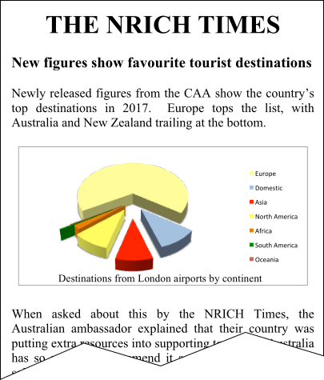
Figure 1

Continent | Total flights | Proportion
Europe | 374496 | 67.8%
Domestic | 57866 | 10.5%
Asia | 52336 | 9.5%
North America | 52259 | 9.5%
Africa | 11925 | 2.2%
South America | 2059 | 0.4%
Oceania | 1442 | 0.3%
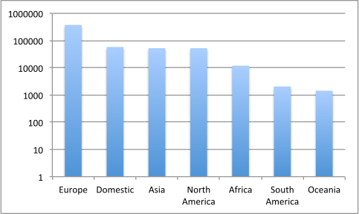
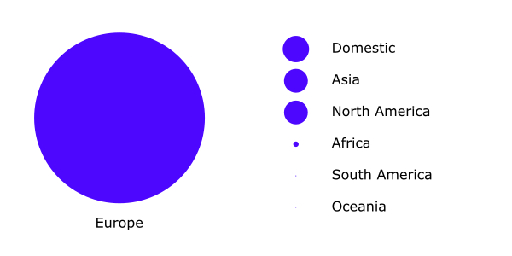
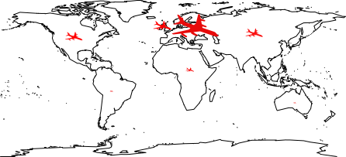
The original data
Figure 4: Number of flights from London airports in 2017
Figure 3: Destinations of flights from London in 2017
Figure 2: Popularity of destinations (by continent) in 2017

