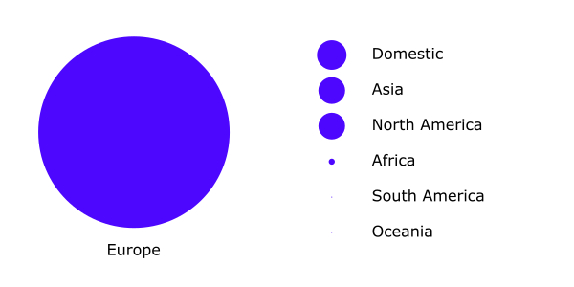
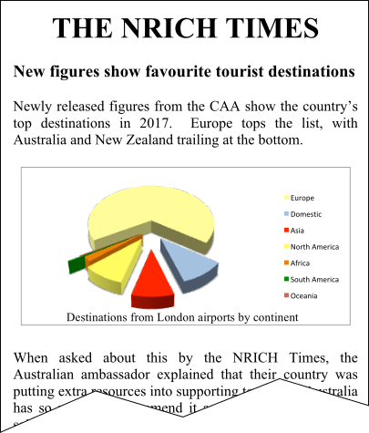
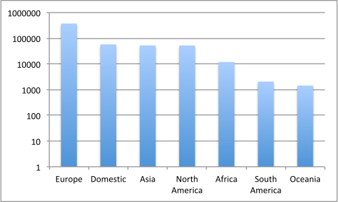
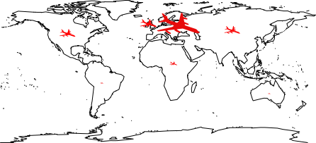
Figure 4: Number of flights from London airports in 2017
Figure 2: Popularity of destinations (by continent) in 2017
Figure 3: Destinations of flights from London in 2017
Figure 1

