Promoting Women in Mathematics

Here’s Sara Zahedi, the woman I told you about
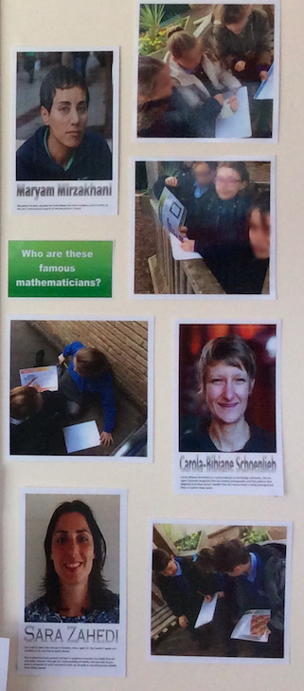
earlier, who won a prestigious EMS prize this year: https://plus.maths.org/content/international-womens-day-2017

Maryam Mizarkhani is the first woman to win a fields medal: https://plus.maths.org/content/mm

I also really like Carola Schonlieb from DAMTP, here’s a reasonable accessible article about her work: https://plus.maths.org/content/what-eye-cant-see
and a video with her https://plus.maths.org/content/mathematical-moments-carola-schonlieb

Also, there are quite a few women in our careers library (interviews with people who use maths in their jobs) https://plus.maths.org/content/CareerII

For example, there’s https://plus.maths.org/content/career-interview-space-scientist-and-science-communicator a space scientist and TV personality

These are all alive, and mostly not famous or historically significant. For dead and significant people, what about

Emmy Noether:
https://plus.maths.org/content/against-odds

FlorenceNightingale:
https://plus.maths.org/content/florence-nightingale-compassionate-statistician

or Sophie Germain or Sofia Kovalevskaya https://plus.maths.org/content/pluschat-20#women

Also, we’ve just finished a series of interviews with 6 women mathematicians here at Cambridge, to complement a photo exhibition that will display portraits of the women
https://plus.maths.org/content/women

Hope that helps!

