Here is a picture taken part-way through a game of Square It. It is blue’s turn next.

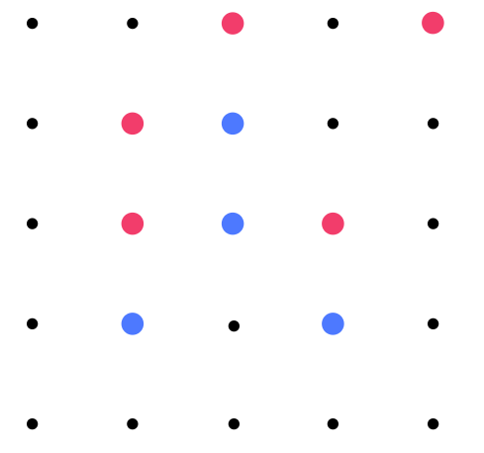

Where would you go if you were the blue player?

The picture below was taken after the blue player had chosen a dot.
Are you surprised at his/her choice?
Why do you think the blue player made that move?

