I made a number line from 0 to 20.
Then I folded it along the 4 and the 8 so that the 0 is on top of the 8 and the 4 is on top of the 12.
I then folded it along the 12 and the 16 so that now the 0 is on top of 8 which is on top of 16 and the 4 is on top of the 12 which is on top of the 20.
The photo below shows these folds:
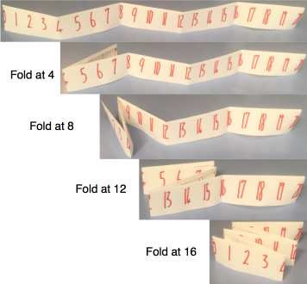

I ended up with some stacks of numbers that are on top of each other.
For example:
- The I in on 7 which is on 9 which is on 15 which is on 17. These five numbers have a total of 48.
- The 0 in on 8 which is on 16 (total 24).
- The 3 is on 5 which is on 11 which is on 13 which is on 19 (total 51).
We will be focusing on totals made in this way (like 48, 24 and 51 above).

The challenges below involve varying the length of the number line. However, you must always start with 0 and each folded section must be the same length.

Challenge 1
Find three different ways to get a 'stack total' of 36 using lengths of 21 to 36 inclusive, showing exactly how you fold the number lines.

Challenge 2
Find as many ways as you can to get a 'stack total' of 48 using lengths of 21 to 36 inclusive, again showing exactly how you fold the number lines.

Challenge 3
Now using lengths from 21 to 50 inclusive, find a way of getting 'stack totals' of 69, 70 and 71 using the same length and the same number of layers.

