Throughout these challenges the touching faces of any adjacent dice must have the same number.

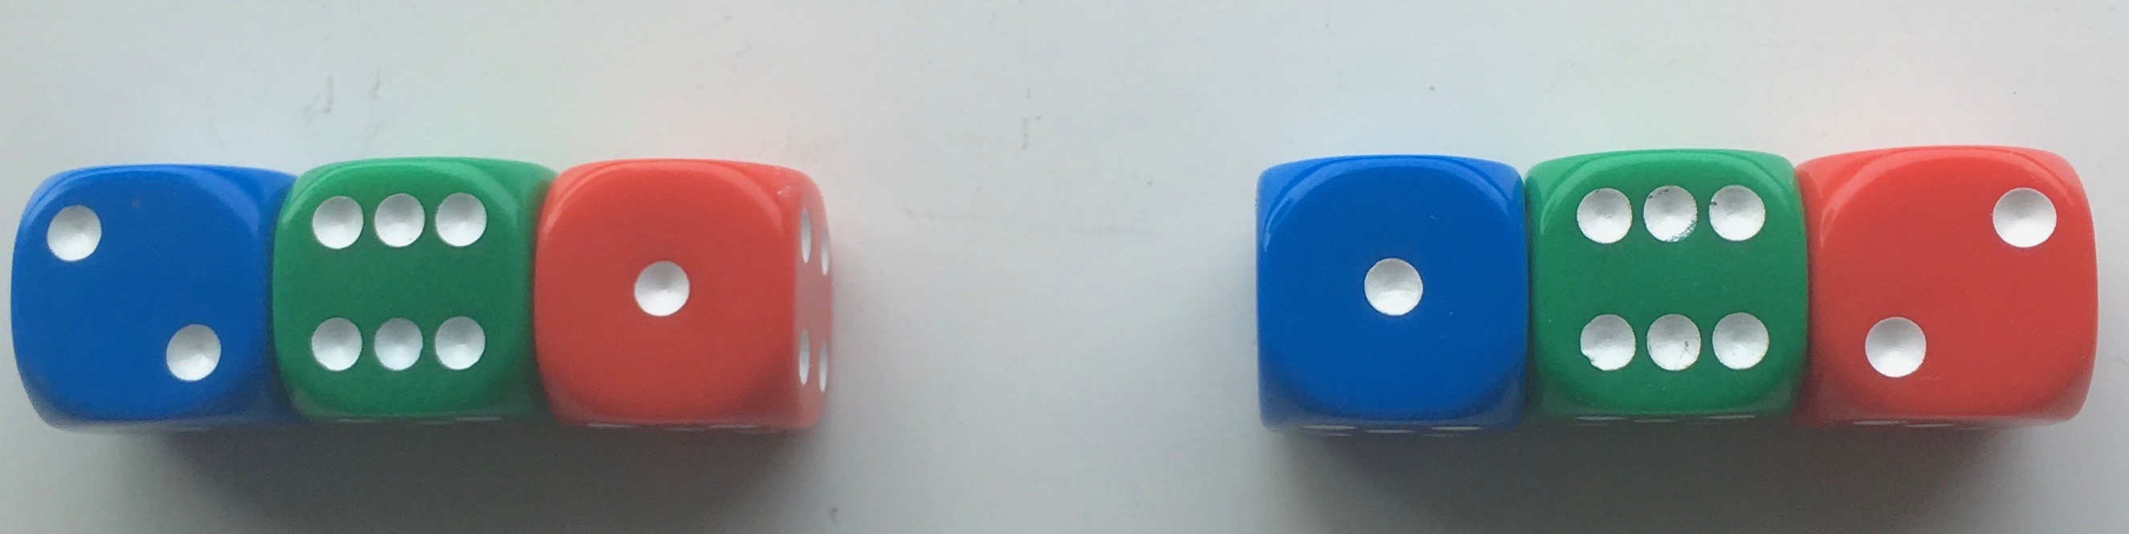
In the picture above, three dice are joined with 4s between the blue and green, and therefore 3s between the green and red.
The total of the numbers on the top is 9.
The two arrangements will be thought of as the same even though they are in a different order and this is true for all the challenges.
For the challenges below, you'll be using four dice.

Challenge 1
Find as many ways as possible of making the total on the top come to each number from 11 to 18 inclusive, keeping to the same joining numbers throughout.
Here is an example:

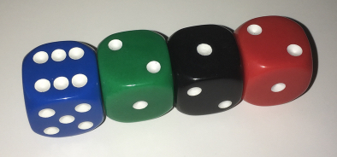

Remember, any touching faces must be a pair of the same numbers.

Challenge 2
Using different joining numbers, find as many different ways as possible to make the tops add up to 12.

Challenge 3
How can you arrange the dice so the total of the tops of the left-hand pair is twice the total of the tops of the right-hand pair?
Can you do it in more than one way?
In the picture below, the top total of the left-hand pair is three times the right-hand pair, not two times.

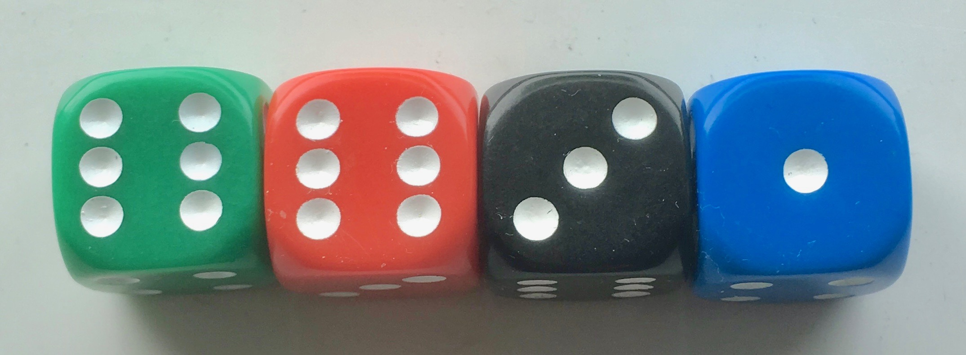

Challenge 4
Can you arrange the dice so the pair on the left-hand side have a top product which is double or treble the right-hand pair product?
Can you do it in more than one way?
In the picture above, the left-hand pair product is nine times bigger than the right.

