What do you notice about this number line?
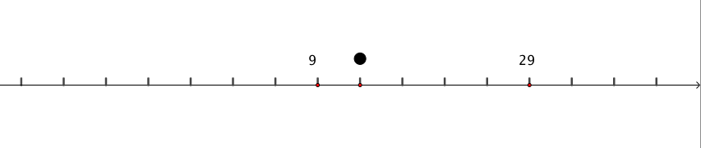
What number would be where the dot is?
How do you know?
Where would 0 be on the line?

Below are some more number lines. Can you work out what number is marked by the dot?

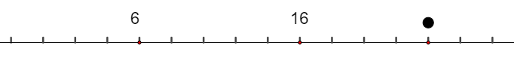

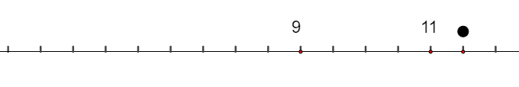

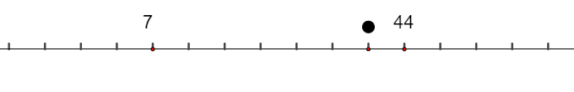

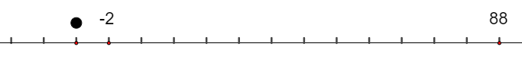
You could also create some of your own challenges.

What makes a challenge easier or harder?

Can you explain your strategies?

