Can you work out the angles in the pictures below?
On the left, a regular octagon is surrounded by congruent kites.
On the right, a regular decagon is divided into two different types of rhombus.
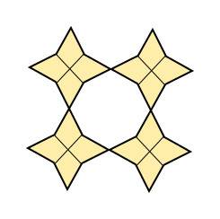 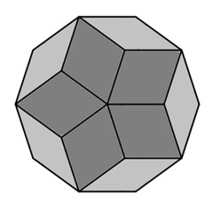

Here are two more polygon puzzles to try.
The first one is a regular nonagon drawn inside an equilateral triangle.
The second is also a regular nonagon, with lines joining vertices to each other and to the centre.
Can you work out the angles?
