Here are the distances (as the crow flies) in kilometres from London to various cities in the world:
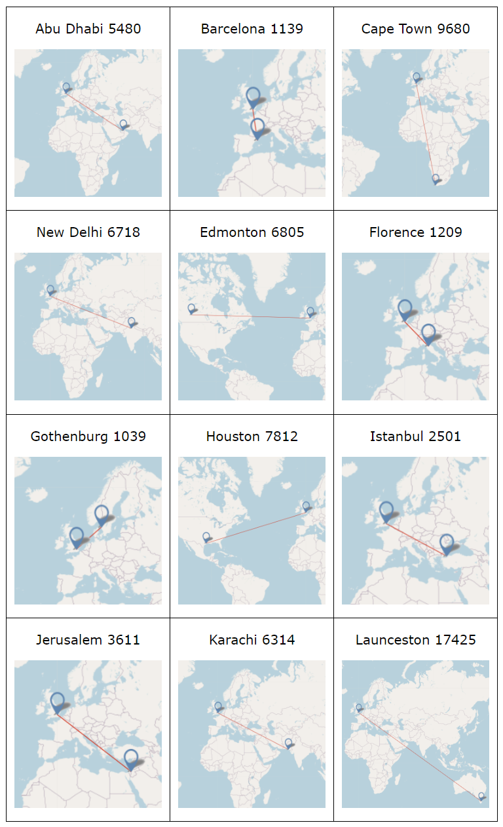
Put these journeys in order according to the distances involved.

