Here are the distances (as the crow flies) in kilometres from London to various cities in the world:

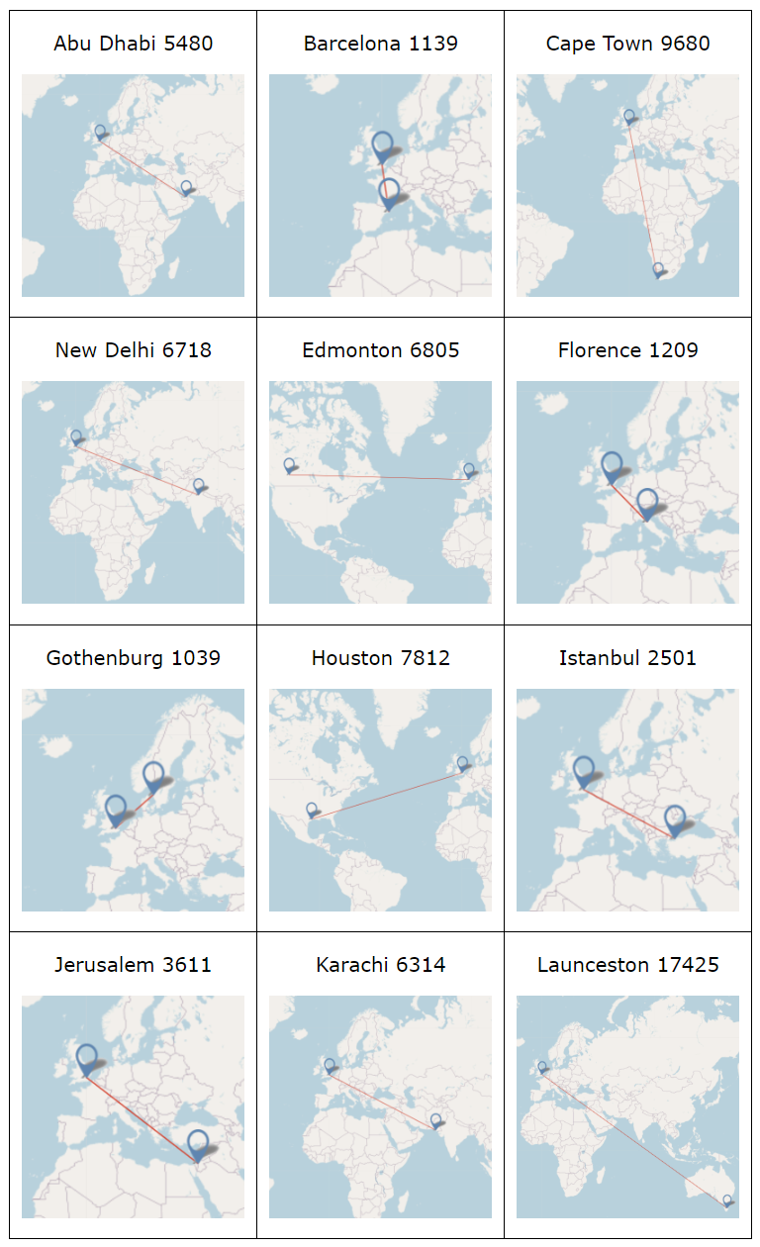

Challenge 1
Once you have travelled the first 1000km, how much further will you have to go for each of the twelve journeys?
Rather than actually performing each calculation, could you say which you think will be the most difficult and which will be the easiest, and why?
Now create some similar questions of your own.

Challenge 2
The distance from Copenhagen to London is approximately 1000km. If you always start at Copenhagen before travelling to London for all of the journeys shown above, how far would you travel in each case?

