How many different sets of numbers with at least four members can you find in the numbers in this box?

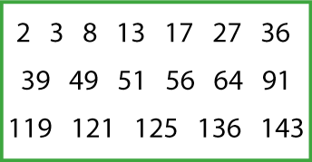

For example, one set could be multiples of 4 {8, 36, … }, another could be odd numbers {3, 13 , … }.

