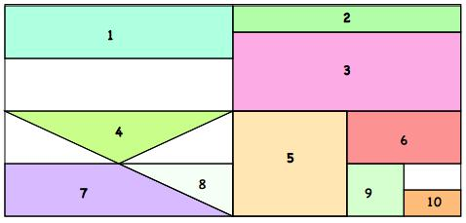

The large rectangle above is divided into a series of smaller quadrilaterals and triangles. Each of the shapes is a fractional part of the large rectangle.

Can you untangle what fractional part is represented by each of the ten numbered shapes?

