The coloured shapes stand for eleven of the numbers from 0 to 12.
Each shape is a different number.
Can you work out what they are from the multiplications below?

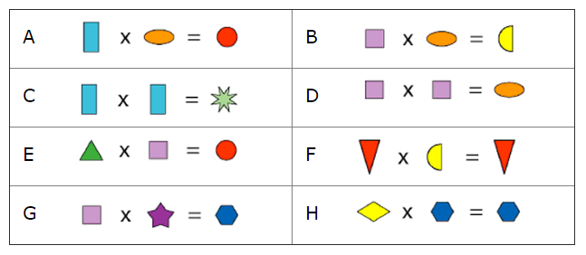

Here are four more clues to help you to work it out:

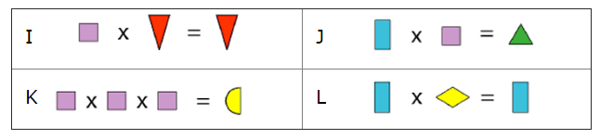

Did you need to use all the clues?

Which clues were the most helpful?

