The coloured shapes stand for eleven of the numbers from 0 to 12.
Each shape is a different number.
Can you work out what they are from the multiplications below?

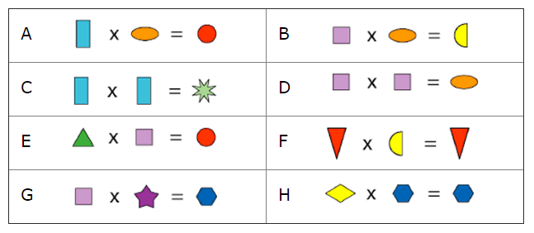

Extension

Once you have worked out the value of each shape above, take a look at the two multiplications below:
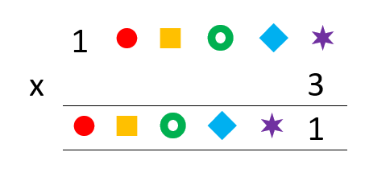
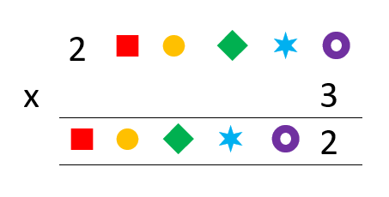

Can you work out the value of the shapes in each product?

