Paper Halving
First we explored the lines of symmetry, we found four. Then we used different pieces of paper to fold and mark them using a ruler. We made sure there were 2 equal pieces.
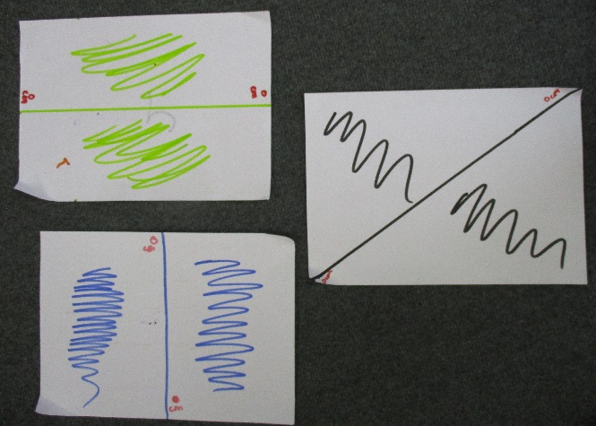
We then took a risk and started to split the paper in different ways. We measured in along the long sides from diagonally opposite corners. For example we measure 7cm in on both sides and drew line to split the paper in half. We also did this with 3 ½ in too as we halved the 7cm.
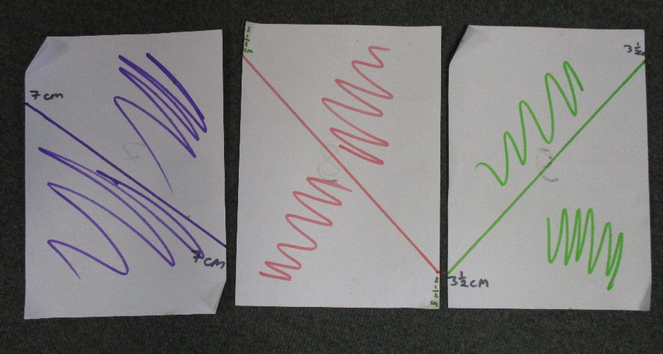
There are lots of other ways we could have halved this paper using this method by measuring in different amounts.

By Suki Year 4 and Audrey Year 3
Mathematical Mayhem Club at North London Collegiate School

