Paper Halving
First we only split the paper into 2 parts. We could do this in three ways.
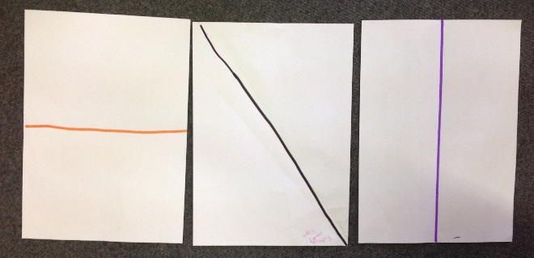
We used a ruler to measure in from the corner so both sides were equal and drew a line. These are two other ways you could make a half.
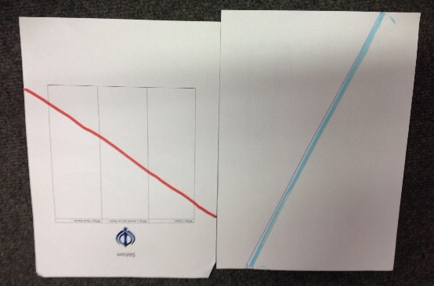
We tried splitting it into quarters and shaded diagonally opposite quarters.
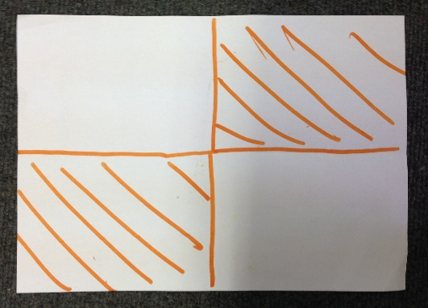
Then we split the paper into 8 8ths and shaded four pieces which makes half in 7 different ways. Altogether we made 13 different ways to make half.
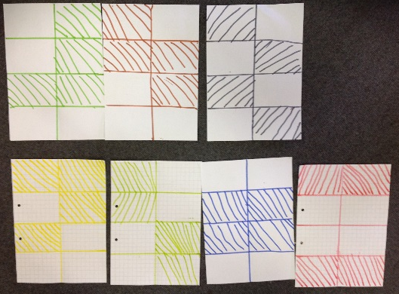
By Siya and Felicity
NLCS year 3

