
We have two different targets and a set of three darts.
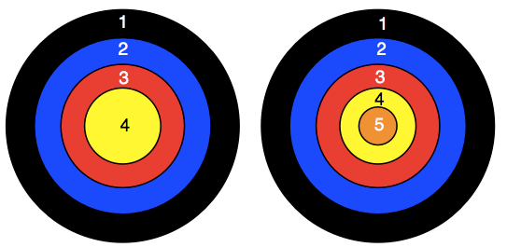

You use three darts for each game. All the darts always hit the target.
An important rule:-
You can only have one dart in the same coloured area on any one target, but you could, for example, have a dart in red 3 on the left target and another dart in red 3 on the right target.
CHALLENGE 1
Each time you have a game, you add up the score of the three darts.
Your challenge is to have four games each with the same total score, but made in different ways.
However, note that 1 and 2 on the left target and 3 on the right target is the same as 1 on the left target and 2 and 3 on the right target, so is counted as just one solution.
CHALLENGE 2
Have three games. The three totals must give three consecutive numbers.
In the nine darts used no number must occur more than twice.
So, when Raj chooses:
Game 1: 2 + 3 + 4 = 9
Game 2: 1 + 4 + 5 = 10
Game 3: 1 + 5 + 5 = 11
This is NOT allowed as three 5s have been used and the maximum is two.

CHALLENGE 3
You now move on to having three targets with four darts for each game.
As before you can only have one dart in any coloured sector of a target.
The targets are:
1, 2, 3
1, 2, 3, 4
1, 2, 3, 4, 5.
Firstly see how many different totals you can make.
Finally find all the ways of getting the set of three consecutive 11, 12, 13
But in a set of three answers you must not use the same number more than three times.
So, when Sara chooses:
Game 1 1 + 2 + 3 + 5 = 11
Game 2 1 + 2 + 4 + 5 = 12
Game 3 2 + 2 + 4 + 5 = 13
This is not allowed as four 2s have been used and the maximum is three.
Find as many answers as you can.

