Here is a close-up view of a tile used to tile a wall at Bayside School in Gibraltar.

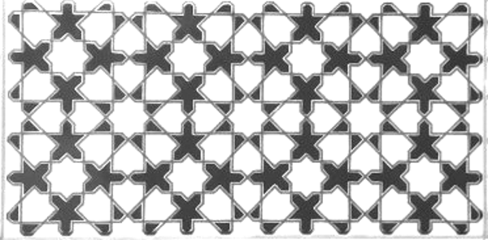

What geometric shapes are there in the tiles?
What angles can you work out?
How many squares are there?
How many eight-pointed stars?

Can you recreate a copy of the tile on plain paper?

