Here is an equilateral triangle with sides of length 1.

Let's define a unit of area, T, such that the triangle has area 1T.
Each of the triangles below has at least two edges whose side lengths are whole numbers.
For example triangle B has sides of length 3 and 4.
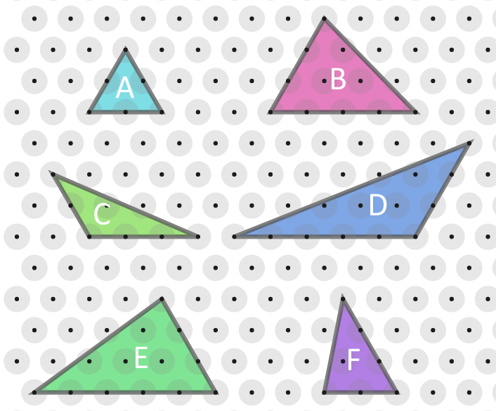
Work out the area, in terms of T, of each of the triangle.
Compare the areas to the whole number side lengths.
What do you notice?
Can you explain what you've noticed?

