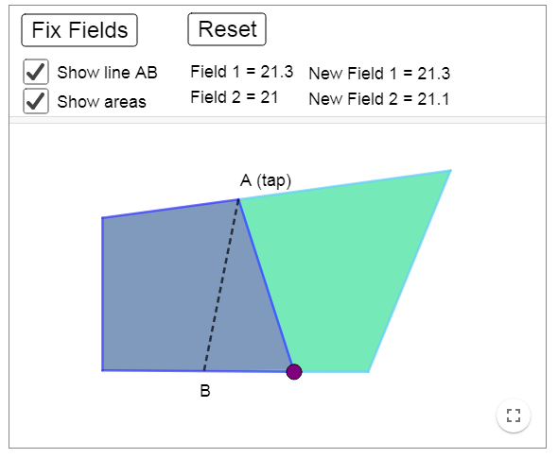

AB= Boundary Line
If we use the rule above, then we can make the boundary strait and same as the original one.

