Davide
Gabriel’s Problem:

Gabriel wrote the numbers 1-9 in a 3x3 grid.
He then multiplied together all the numbers in each row and wrote the resulting product next to that row.
He also multiplied the numbers in each column together, and wrote the product under that column.
He then rubbed out the numbers 1-9.

Solution:
The numbers we have to complete the square are form 1 to 9. Of these 2, 3, 5, 7 and 9 are prime numbers.

The problem also tells us that the numbers must have a product that is written on the outside of the square.

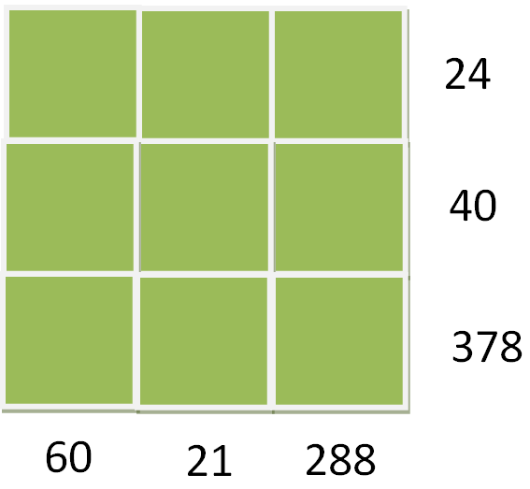

Therefore, by factorising the products we can find some numbers in common and then find the rest with simple division.

By factorising 24= 2³ × 3 and 60= 2²×3×5 we can see that the common number is 2. So the 2 will be in the top left-hand corner.

Now let’s factorise 21= 3×7 so the number in common in the factorisation of 24 and 21 is 3.

Then, without factorising we now that the number in the top right-hand corner is 4 because 2×3×4=24.

Now the square should look like this:
2 3 4 24
… … … 40
… … … 378
60 21 288

The numbers we have left are 1, 5, 6, 7, 8 and 9.

The factorisation of 40= 2³x5 and the factorisation of 60= 2²×3×5, so the numbers in common are 2 and 5 but we already used 2 so the only number is 5.

Therefore we can now find the number above 60 because if 2×5×y=60 then y=6.

21 and 40 only have number 1 in common so the centre square would be 1.

If 3×1×A=21 then A=7.

The only remaining numbers now are 8 and 9, but if 5×1×C=40 then C=8 and then the last number will be 9.

So the square would appear to be:

2 3 4 24
5 1 8 40
6 7 9 378
60 21 288

Check:
2×3×4=24
5×1×8=40
6×7×9=378
2×5×6=60
3×1×7=21
4×8×9=288

