This right-angled triangle has a base of 3 and a height of 6 units.

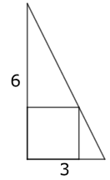

How might you construct the square, which just touches the hypotenuse?
Can you work out the side length of the square?
Can you think of more than one way to work it out?

What if the side lengths of the triangle were 12 and 4 units long?
What if they were a and b units long?

