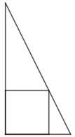
A right-angled triangle has a base of a and a height of b units.
How might you construct the square, which just touches the hypotenuse?
Once you’ve had a go at solving this, have a look at the three methods below.
Can you take each starting point and turn it into a solution?
Method 3
Can you see how to create the rectangle on the right from
the rectangle on the left?
Find expressions for the areas of the two rectangles.
How could you use these expressions to find the side
length of the square?

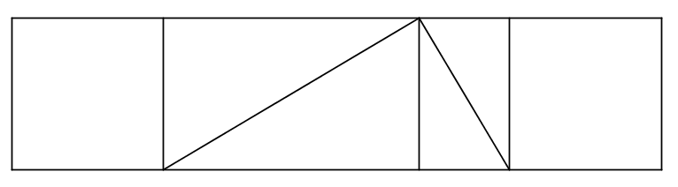
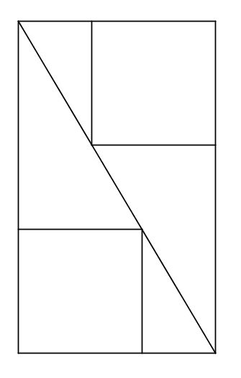
Method 1
There are some similar triangles in the image below. How could you use these to find the side length of the square?
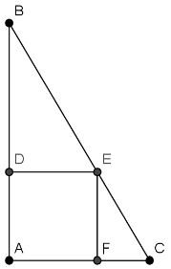
Method 2
There are some similar triangles in the image below. How could you use these to find the side length of the square?
