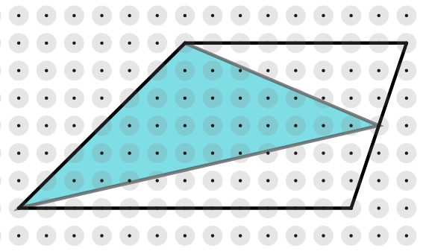
In the two trapeziums below, we have drawn triangles by joining the vertices of one of the non-parallel sides to the midpoint of the opposite side.
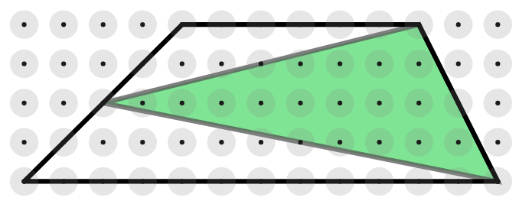

Is there a relationship between the area of each trapezium and the area of the shaded triangle contained within it?
Draw some more trapeziums and construct triangles inside them in the same way. Does the same relationship hold?
Can you find a way to prove that your relationship will always hold for any trapezium?

