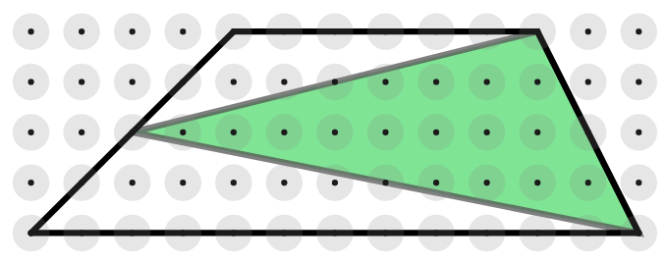
Inside a trapezium, a triangle can be drawn by joining the vertices of one of the non-parallel sides to the midpoint of the opposite side.
You may have noticed that the area of the triangle is always half of the area of the trapezium.
Once you have had a go at proving it, look at the possible starting points below.
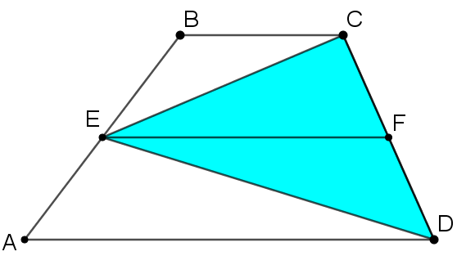
Can you take each starting point and develop it into a full proof?
Starting Point 1
In this diagram, an extra line has been drawn joining E, the midpoint of AB, to F, the midpoint of CD.
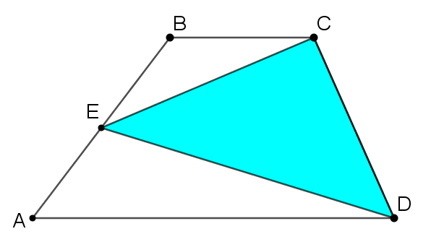
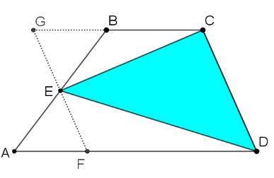
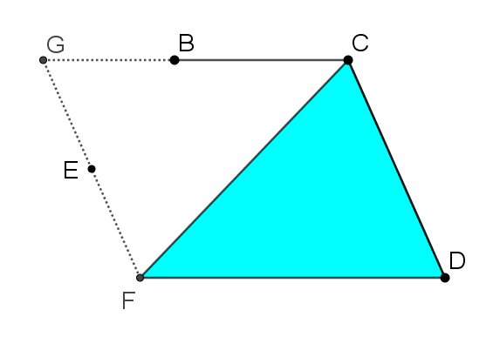
Starting Point 2
Take a look at this sequence of three images. What happens at each stage?
Starting Point 3
Take a look at the image below. Can you see how the trapezium ABCD has been transformed to create this image?
