Starting Point 1

In this diagram, an extra line has been drawn joining E, the midpoint of AB, to F, the midpoint of CD.
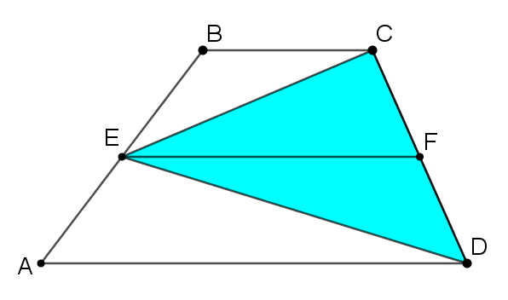
How could you use this diagram to show that the area of the triangle is half the area of the trapezium?

Starting Point 2
Take a look at this sequence of three images. What happens at each stage?
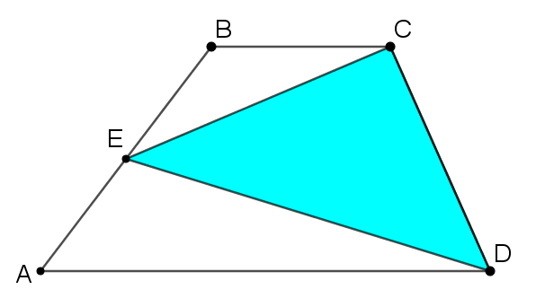
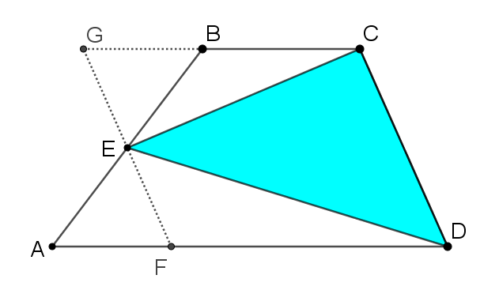
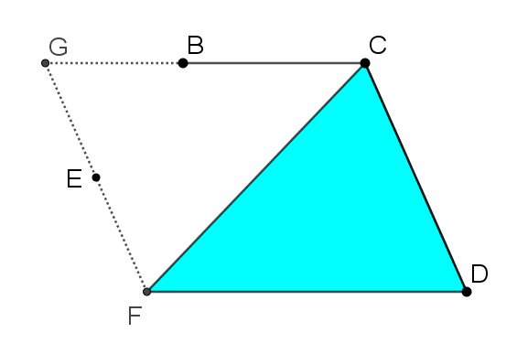
How could you use this sequence of three images to create a proof that the area of the triangle is half the area of the trapezium?

Starting Point 3

Take a look at the image below. Can you see how the trapezium ABCD has been transformed to create this image?
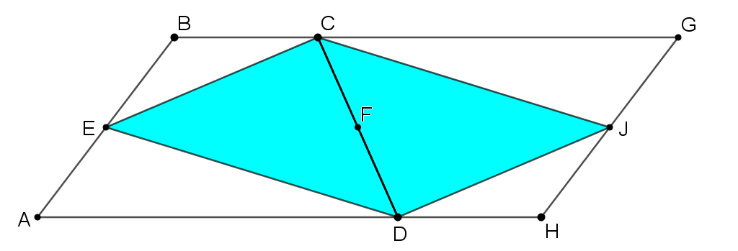
How could you use this image to prove that Triangle CED has half the area of Trapezium ABCD?
Below are two more images that might help.
