Here is a five-pointed star:
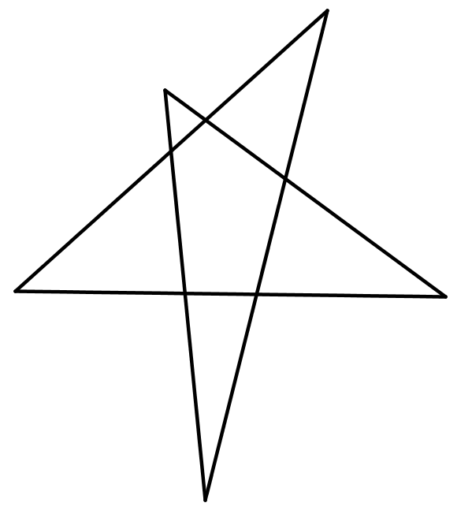
Draw a couple of five pointed stars of your own, making sure your lines are nice and straight!
Measure the interior angles at the five points and add them together.
What do you notice?
Here is a seven-pointed star:
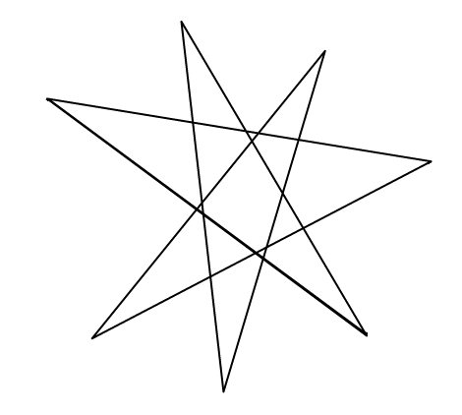
Draw some seven-pointed stars of your own.
Measure the interior angles at the seven points and add them together.
What do you notice? Can you explain your findings?

