AHI is an isosceles triangle:
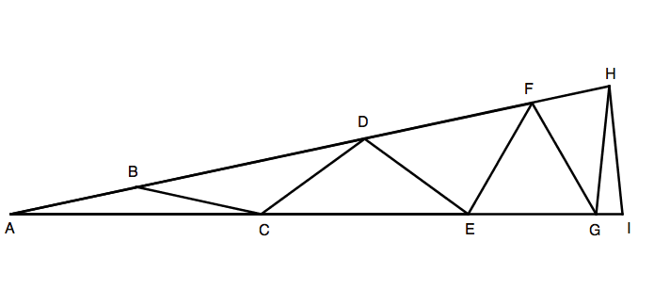
Within the triangle are seven other isosceles triangles: ABC, BCD, CDE, DEF, EFG, FGH, GHI.
The eight line segments AB, BC, CD, DE, EF, FG, GH, HI are equal in length.
Calculate the three angles of the isosceles triangle AHI.
Extension:
Can you construct similar isosceles triangles, made up of a number of smaller isosceles triangles, in which the angles are all whole numbers?
If the isosceles triangle is composed of n isosceles triangles, and angle BAC = x, what are the values of the other angles of the triangle?

