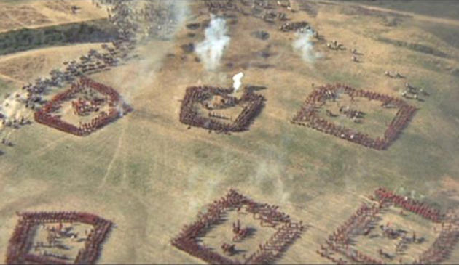
In Napoleonic battles a hollow square was a popular formation for an infantry battalion designed to cope with Cavalry charges.
For example, this picture shows a recreation of Wellington's army at Waterloo.

Below are two diagrams showing symmetrical hollow square formations.
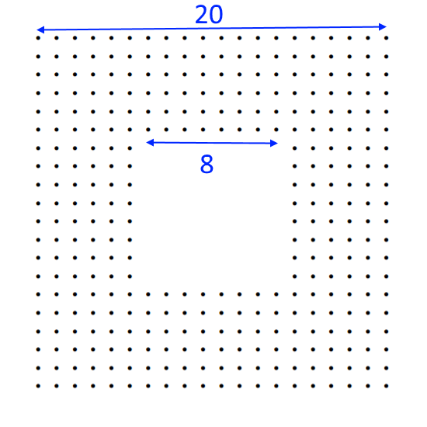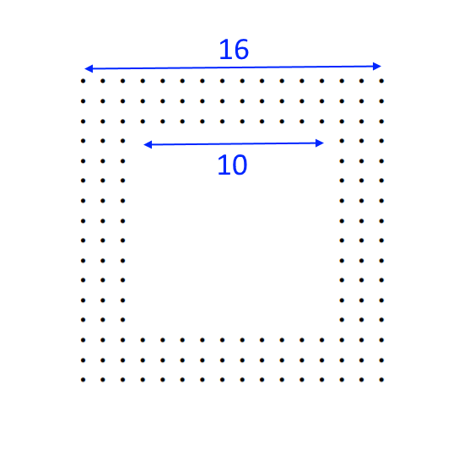
How could you quickly work out the number of dots in each?

A general has 960 soldiers. How many different ways can he arrange his battalion in a symmetric hollow square?
What can you say about battalion sizes that can't be arranged as symmetric hollow squares?
Can you find a general strategy for arranging any possible battalion into all possible hollow squares?

What about hollow squares that are not symmetric...?

