Each line is one side of the named quadrilateral. Can you draw the other three sides?
In each case, try to find the quadrilateral with the largest area (given in brackets).

1. Rectangle (6) |  | 2. Square (8) |  | 3. Rectangle (4)
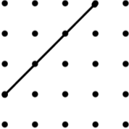 |  | 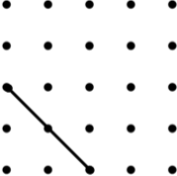 |  | 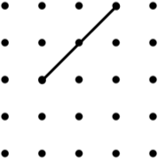
4. Isosceles Trapezium (12) |  | 5. Parallelogram (9*) |  | 6. Kite (8)
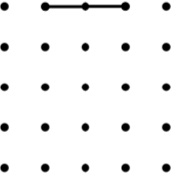 |  | 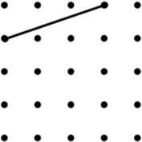 |  | 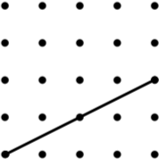
7. Parallelogram (6) |  | 8. Square (5) |  | 9. Kite (12)
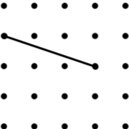 |  | 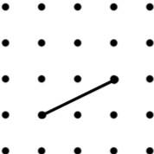 |  | 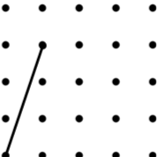
10. Rhombus (4*) |  | 11. Parallelogram (3*) |  | 12. Kite (6)
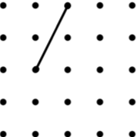 |  | 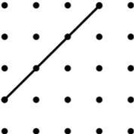 |  | 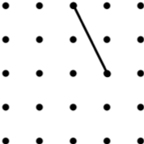
13. Arrowhead (6) |  | 14. Kite (8) |  | 15. Rhombus (8)
 |  | 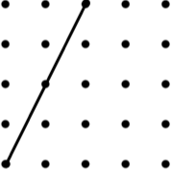 |  | 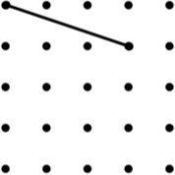
16. Rhombus (3) |  | 17. Arrowhead (4) |  | 18. Trapezium (9)
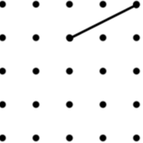 |  | 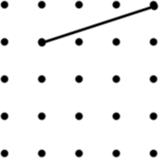 |  | 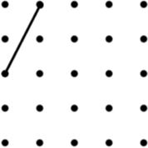
19. Parallelogram (8) |  | 20. Isosceles Trapezium (8) |  | 21. Kite (3)
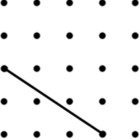 |  | 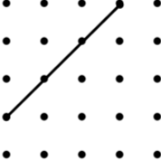 |  | 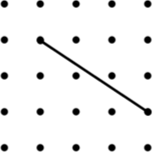
22. Arrowhead (4) |  | 23. Kite (9) |  | 24. Trapezium (9)
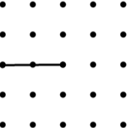 |  | 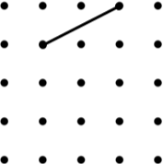 |  | 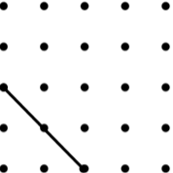

An * indicates that there is a “special” quadrilateral with a larger area than the one given. For example, the largest parallelogram might be a square or a rectangle.

