Here is a pattern made from regular pentagons:
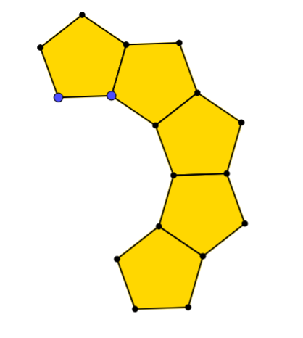
If the pattern continued, do you think it will form a complete loop or will the pentagons overlap?
You could explore by drawing or tracing more pentagons, or by cutting some out.
Once you've had a chance to explore, here are some questions you might like to consider.
How many pentagons form a ring?
How many decagons would form a ring?
Why do they fit together so neatly without overlapping or leaving a gap?
What about other polygons?
Can you always make a ring?
Is there a way to predict how many polygons you need to form a ring?

