Suppose we have a garden shed with a roof made from five wooden beams laid out like this:

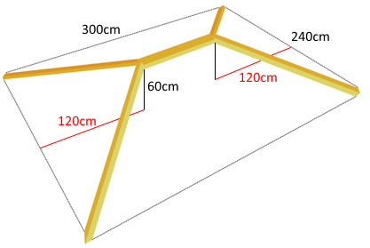

Each of the four sloping beams is the same length.
The roof of the shed is 300cm long, 240cm wide and 60cm high.

What is the total length of wood needed to make these five main beams for the roof?

Can you reduce the amount of wood needed by changing the lengths marked in red?

