Can you match each graph to one of the statements (so that each graph is paired with a single statement)?
Assume that all the graphs have an equation of the form $y= ax^{2}+bx+c$

1. 2.
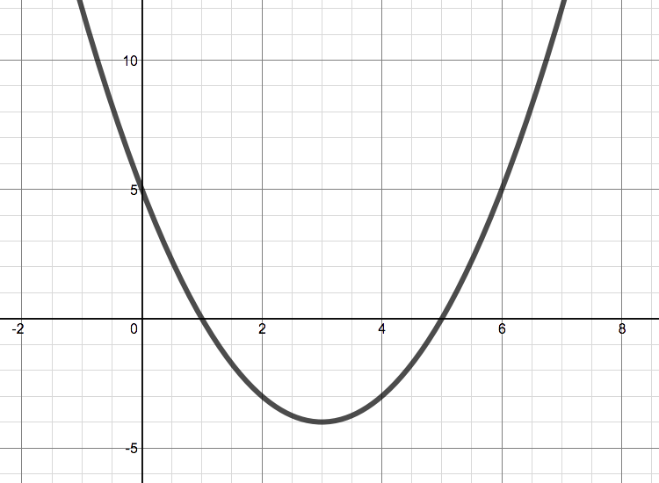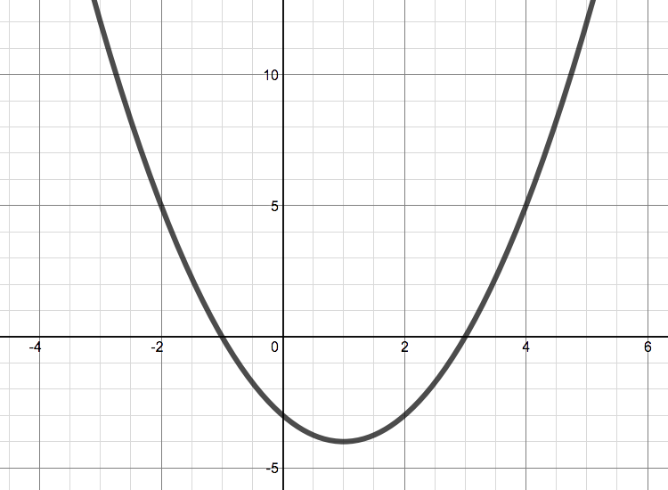

3. 4.
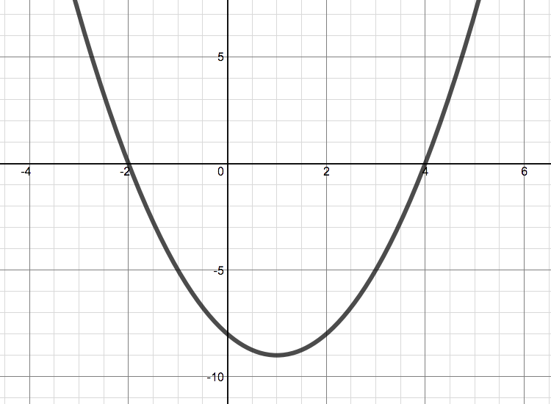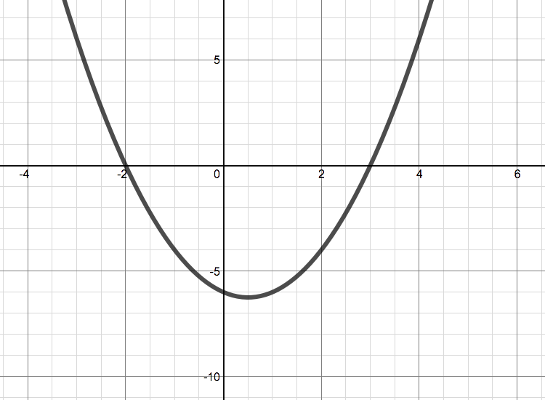

5. 6.
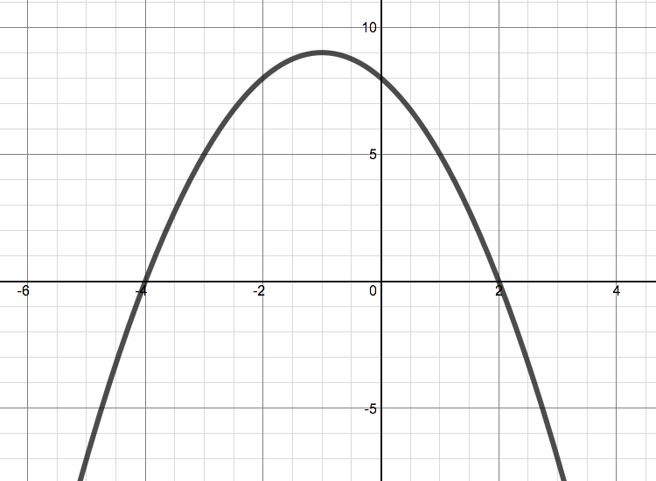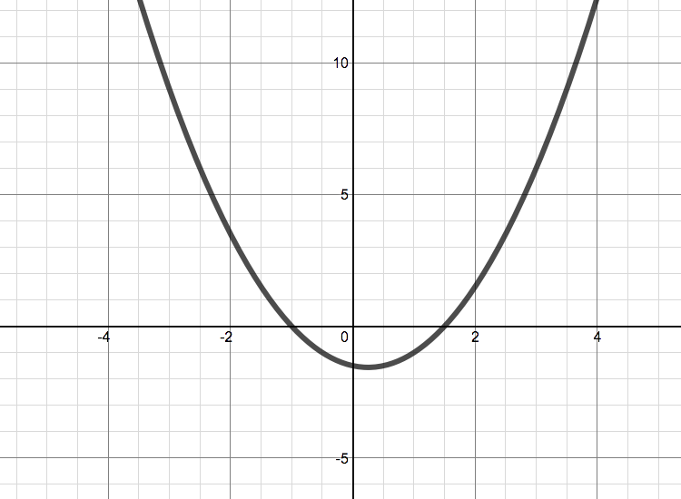

7. 8.
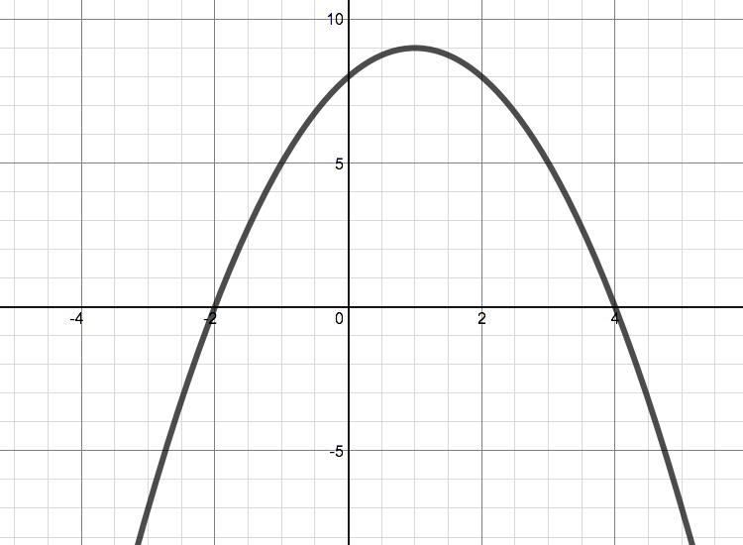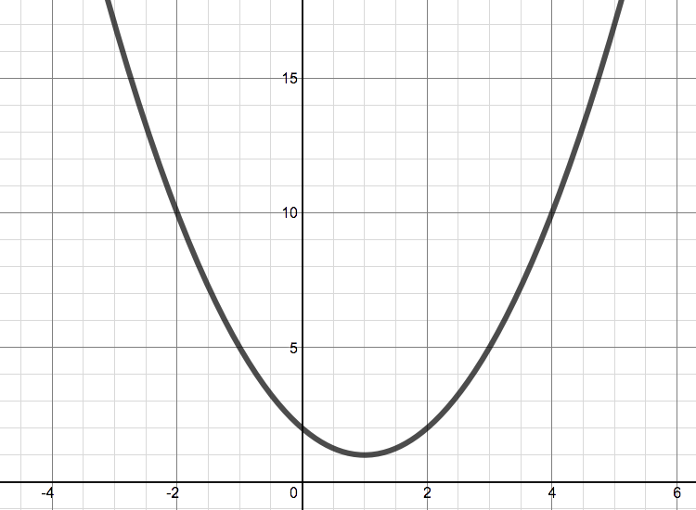

9.
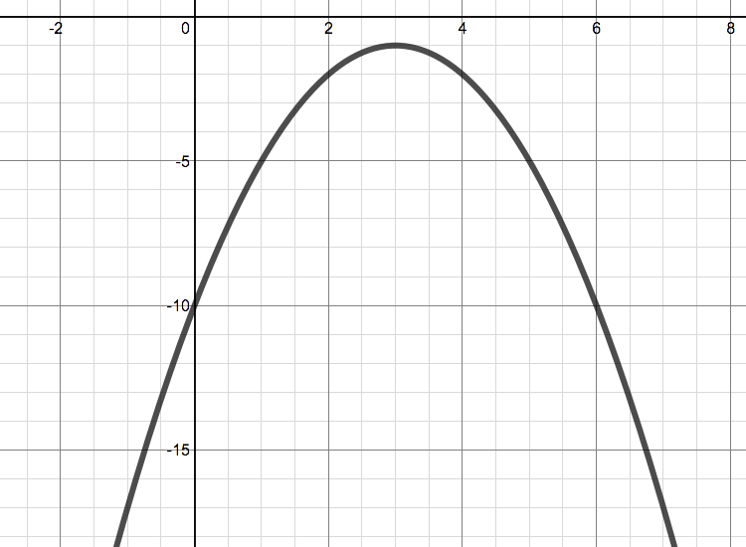

(a) The line of symmetry of this graph is x=3
(b) This function has a non-integer root
(c) The line of symmetry of this graph is x=k, where k<0
(d) The y values for this graph are all greater than 0 (that is, y>0)
(e) The vertex of this graph lies on the line x=1
(f) The constant term of this function is −8 (that is, c=−8)
(g) The sum of the roots of this function are 6
(h) The points (0,8) and (2,8) both lie on this curve
(i) The sum of the roots of this function is an odd number (that is, b is odd)

