Place the digits 1 to 7, one in each region, so that the circles all have the same total.
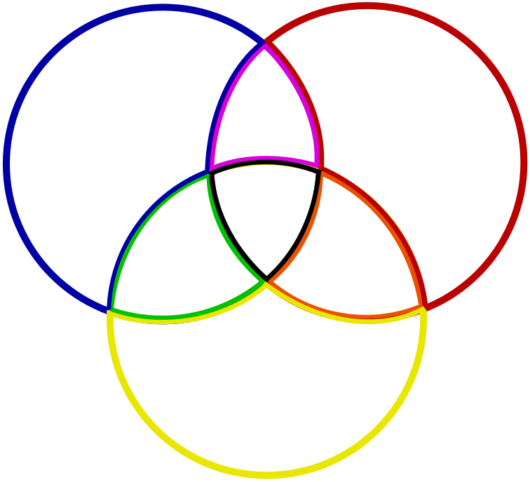
Can you also show that:
- you cannot have a circle total of 16 with 4 in the centre?
- you cannot have circle totals greater than 19 or less than 13?
- you cannot have anything other than 1 in the centre for a circle total of 13?

Five Rings
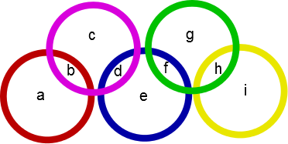
These five rings create nine regions, labelled a to i above. Using each of the digits 1 to 9 exactly once, can you place one number in each region so that the sum of the numbers within each ring is the same?

Can you find more than one solution?

Show that for any solution the sum of the numbers in the overlaps (b, d, f and h) must be a multiple of 5.

Using this, can you find a lower and an upper bound for the possible ring totals?

Is there a solution for every ring total between the lower and upper bound?

