Sinead has 10 pockets and 44 one pound coins.

She wants to put all these pounds into her pockets so that each pocket contains a different number of coins.

Prove that this is impossible.
What is the minimum number of coins Sinead would need in order to be able to do this?

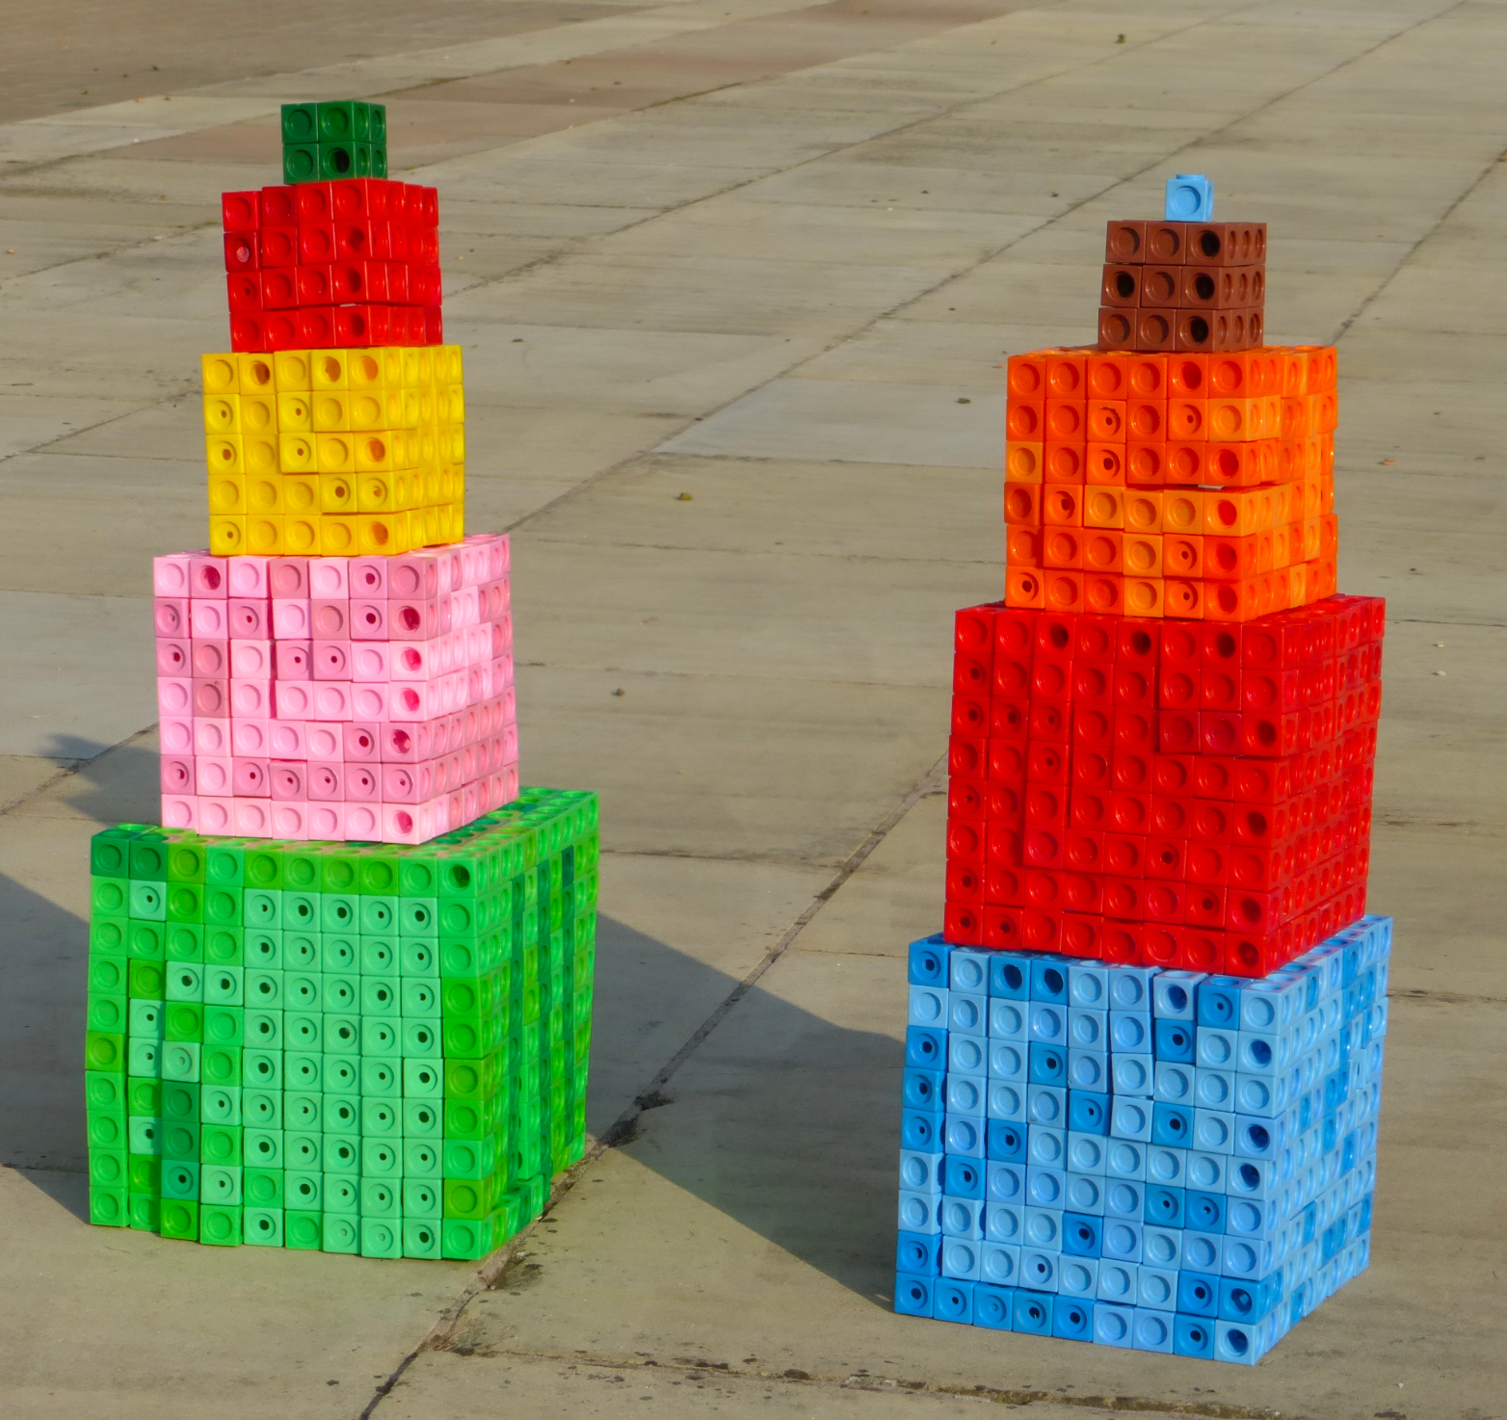
Abbie has a set of 10 plastic cubes, with edges of lengths 1, 2, 3, 4, 5, 6, 7, 8, 9 and 10 cm. She tries to build two towers of the same height using all of the cubes.
Prove that this is impossible.

If Abbie has a set of n plastic cubes, with edges of lengths 1 to n, for which values of n can Abbie build two towers of the same height using all of the cubes?

Eustace is adding sets of four consecutive numbers. He wants to find a set where the total is a multiple of 4.

Prove that this is impossible.

