Take sixteen dice - six of one colour and ten of another. Here we have chosen six blue dice and ten red dice.
Warm up: check that the total of the faces showing is 84 when the dice are arranged as shown:
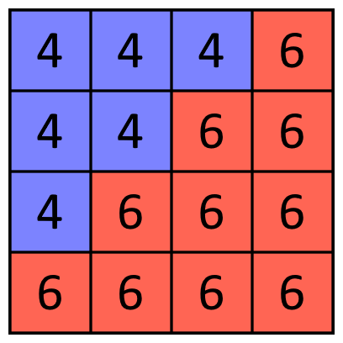

To play the Six Ten Total challenge:
- All the blue dice need to have the same number on the top.
- All the red dice need to have the same number on the top.
- There always needs to be six of one colour and ten of the other.
- There always needs to be a difference of two between the numbers on the blue and red dice.
The main challenge
What are the possible arrangements when you choose your own numbers for the dice using the rules above?
What is the total for each of these arrangements?
What do you notice about your arrangements and the corresponding totals?
Explain what you notice. What else do you notice?
Taking it further
Can you prove any of the things you’ve noticed from the main challenge are always true?
Instead of having a difference of two between the numbers showing on each face of the blue and the red dice, choose a new difference.
Now, what totals can you find? What do you notice? Explain what you notice.
Final challenge
Can you predict - without having to make them - what numbers need to be on the faces that you can see on the blue and the red dice to make a total of 42?
Are there more ways to make a total of 42?
Explain your reasoning.
What happens if you change the number of blue and red dice yet keep the structure the same? It must be a square and both sets of dice must still make triangles.
Can you make 42?
Explain your reasoning.

