Take a look at these pictures:
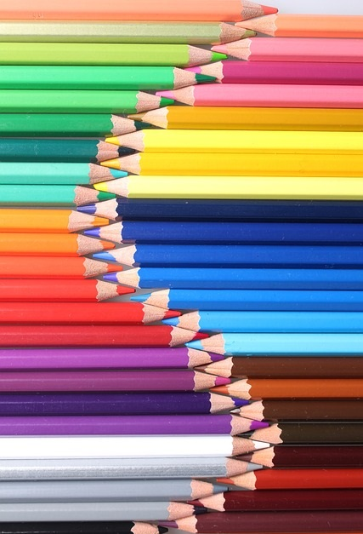

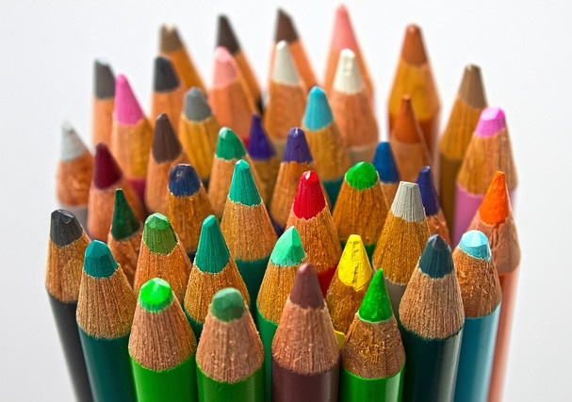
Estimate how many pencils you can see in each one.
What was your method?
How else could you do it?
Is there one way that is particularly useful? Why?

