We start with any four numbers (not zero!):

We then add them in pairs and place the total above them:

And we then add in pairs the new numbers we just got:

We do the same with those two numbers to get our final number:
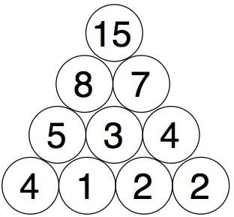
You need to find four starting numbers to place at the bottom so that the top number will be 15.
Try to find as many sets of four starting numbers as you can.
Think about good ways to do this. Maybe use a system!
What little change can you make to the rules to explore again?
What new ideas can you think of to make this different? Explore those!

