This challenge is about dividing a three-digit number by a single-digit number.
Begin by deciding which number you are going to be dividing by. This is your divisor.
Your challenge is going to be to come up with some rules for this divisor.
Now generate a three-digit number. This is your dividend.
You could use some spinners to generate the digits, you could use dice or could just use your imagination!
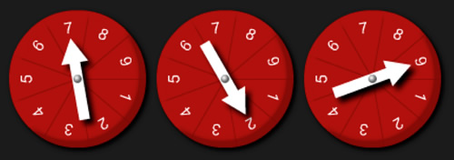
Now divide your dividend by your divisor. Record the answer.
Create other dividends and divide them by the same divisor. Record the answers.
Look carefully at the answers. When is the answer a whole number? When is there a remainder of 1?
Can you spot any patterns?
Can you come up with any rules?

