This challenge is about finding the difference between numbers which have the same tens digit.
Here are two examples where I've decided to use numbers which have two tens:
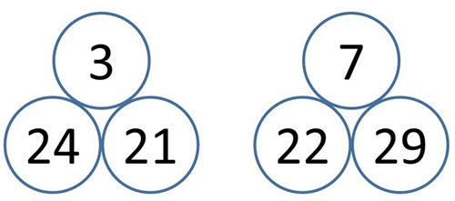
The number above is always the difference between the two beneath it.
Can you find different pairs of numbers with a difference of 1 or 2 or 3 or 4 ... and so on?
Can you find more than one way of doing it?

