In the calculation below, the box represents a missing digit:
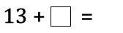
What could go in the box? What would the total be each time?
Which is the highest/lowest total?
Which totals are odd/even?

