One of the elements of any NRICH CPD session is a discussion about rich tasks - after all, our website home page welcomes you to 'the home of rich mathematics'. Another phrase that frequently crops up is 'low threshold high ceiling tasks'. So are they the same? If not, how are they different?
Let's tackle low threshold high ceiling (LTHC) first. The phrase conjures up a picture of a doorway with a low step into it. LTHC tasks have very easy access - they are suitable for practically anybody to have a go. Step into the room, have a good look around and explore. There may be some walls preventing you from moving too far left or right or straight ahead, but what about upwards? That ceiling is a very long way off! You'll have to do some climbing! LTHC tasks have easy access but lots of potential for those who feel brave to climb up to the same kind of, but more sophisticated, mathematics.
Dice in a Corner is a good example of a LTHC task for the primary classroom. Because it is easily accessible you can use it with the whole class at the same time. If you're familiar with this task, read on. If not, take a few moments to play around with the ideas.
It's LTHC because the entry point is very low and only requires following instructions about the positioning of the dice, and addition of five or more single digit numbers.

Dice in a Corner

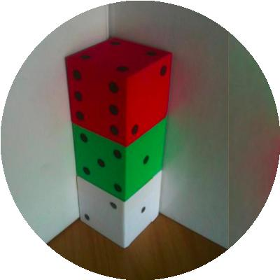

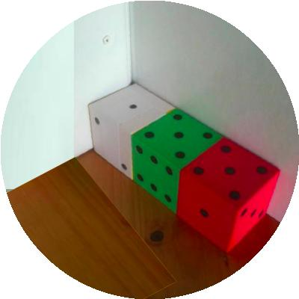
There are three dice sitting in the corner with the simple rule that where two dice meet there must be the same numbers facing each other.
So, in the first picture above there are 3's at the bottom of the red dice and on the top of the middle green and there are 4's on the bottom of the green dice and the top of the white dice. The numbers on the seven faces that can be seen are then added and make 21.
In the second picture above there are 4's at the left of the red dice and on the right of the green dice and there are 3's on the left of the green dice and the right of the white dice. The numbers on the seven faces that can be seen are then added and make 23.

Your challenge is to arrange dice (using at least 2 and up to as many as you like) in a line from the corner, so as the faces you can see add up to 18 (instead of the 21 and 23 above), in as many ways as possible.
Each line of dice must be along or up a wall (or two walls). A line going up is counted the same as a line going along. Remember the dice must touch face to face and have the same numbers touching. The lines of dice must be of a single thickness, so this one below is not allowed;
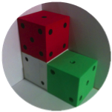
It's LTHC because the next step is exploration with lots of choices - so less confident children may work with just two dice whilst others may use three or more.
It's LTHC because some children will work randomly, others through trial and improvement, whilst the more sophisticated thinkers will be noting patterns and devising a strategy. The challenge then brings the results of all that investigating together.
The task is also LTHC because children will use different ways to record their results. Some children need to be challenged to record using pen and paper whilst others can
use photographs to record their working. If you look at the solutions sent in you can see variations on this.
And finally it's LTHC because of the different levels of explanation and justification that it can elicit.

By comparison, rich tasks conjure up a different picture. Here the experience may be of stepping in through a very small door and then finding yourself in a corridor with many alternative paths from which to choose. You may discover some surprises along your chosen route, or catch a glimpse around a corner of something which intrigues you. You may discover that some paths take you into different rooms altogether. Rich tasks often have a definite starting point but a choice of lots of possible routes through to different end points.

An example of a rich task for primary classrooms is Got It. If you're familiar with this task, read on. If not, take a few moments to play around with the ideas.
Got It is rich because it starts from a relatively closed challenge - can you get to 23? - but then offers lots of other routes.
It's a rich task because it combines fluency and mathematical reasoning - fluency in terms of addition and subtraction, reasoning in working backwards and making conjectures about what will or won't work.

It's rich because children find it an intriguing context.
It's rich because it allows children to
invent their own questions which arise naturally out of the investigation - 'what if the target number was different?'; 'does it matter who goes first?'.

Got It

The interactive for this task can be found here.
Got It is an adding game for two players. You can play against the computer or with a friend. It is a version of a well known game called Nim.
Start with the Got It target 23.

The first player chooses a whole number from 1 to 4.

Players take turns to add a whole number from 1 to 4 to the running total.

The player who hits the target of 23 wins the game.
Play the game several times.
Can you find a winning strategy?
Can you always win?
Does your strategy depend on whether or not you go first?
Tablet/Full Screen Version

To change the game, choose a new Got It target or a new range of numbers to add on.
Test out the strategy you found earlier. Does it need adapting?
Can you work out a winning strategy for any target?
Can you work out a winning strategy for any range of numbers?
Is it best to start the game? Always?
Away from the computer, challenge your friends:
One of you names the target and range and lets the other player start.
Extensions:
Can you play without writing anything down?
Consider playing the game where a player CANNOT add the same number as that used previously by the opponent.
Click here for a poster of this problem.
It's rich because it encourages collaboration and discussion - as most games do.
It's rich because it supports different approaches and different responses. Some children will enjoy playing the game lots of times and seeing if they can pattern spot. Some will work systematically using smaller numbers and work up to the challenge of 23.
It's rich because working on it reveals patterns and generalisations (which numbers are 'good' numbers to land on if you want to win – why?).

Of course there are some excellent, very useful tasks which are both LTHC and rich - have a look at Bracelets for example. It's accessible to pretty well everyone but offers possibilities to progress in exploring number patterns, from simple to much more complicated. It's an intriguing context and allows children to invent their own questions, find their own routes through it, and make connections and generalisations too.
Are you tempted? If you feel you need an excuse, both these kinds of tasks are ideal as formative assessment opportunities. You will find out so much more than you expected by observing children's reactions to LTHC and rich tasks.
You can read more about rich tasks here, and low threshold high ceiling here.

Bracelets

Well, in this country, and perhaps in yours, lots of young folk are wearing bracelets - both girls and boys. I was looking at some that my students wear and found that some were magnetic!

Many seem to have beads that are spherical and they go around the wrist quite comfortably. There are lots of different sizes and some have large beads and some quite small beads.

I suppose that most wrists are kind of oval - squashed circles - in shape and with the string or wire through the beads they fit very well.

It was playing with the magnetic beads off the person's wrist that gave me some ideas. There were 18 beads altogether and they were all the same colour but I've chosen to show them in a variety of colours!

I found I could put them into different shapes:-
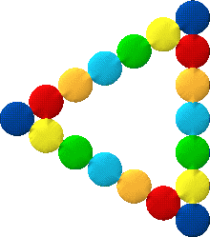

mind you, you'd have to have a triangular wrist for them to stay like that!

Now suppose we play around with this idea and make a rule that there has to be some shaped hole in the middle for a wrist. But we'll allow that to be all kinds of shapes :- vaguely triangular, rectangular, hexagonal etc.

You could try this out with marbles, circular counters, tiddly-winks, coins or with a drawing program on your computer.

I think we'll make a rule that the circles/spheres have to be the same size and you don't have to imagine that they're magnetic!

So here are some that I found with 18 beads:-
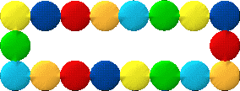

I liked that one as it is the longest rectangle you could make - remembering to keep a wrist-hole. I then went on to:-
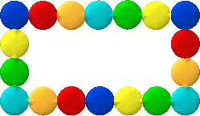

and then, almost a square :-
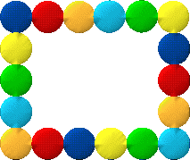

I like the next one - although it was a little hard to do on the computer!
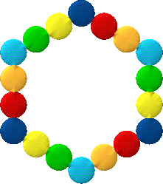

Have a go at making these with your circles!
Well, now it's time to explore, to see what other bracelets you can make. Remember that there's to be a "wrist-hole". The shapes should be kind of "regular" but not strictly so, because then we could not use rectangles.
Other things to investigate:-
- If you make a particular shape with 18 and then the next size up comes when you use 24, is there going to be the next size up at 30?
So whatever shape you make, how many will you need to make the next size up? How does each shape grow? Look at the first shape I made using 24:-
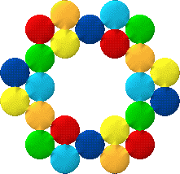

What will the next size up of this look like?
- What are good numbers of beads to use? Why?
- What's the smallest number of beads that will allow you to make two identical bracelets? Why? How many will you need to make three of those?
- If you make a bracelet with just one thickness of beads then how many will you need to make one that has a double thickness? Here's one I did by making the wrist-hole smaller and getting it to be twice as thick:

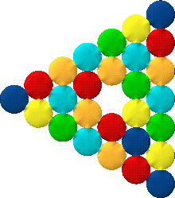
- Would cube beads lend themselves to exploring slightly differently? What about tetrahedral beads?
- What about ...?

