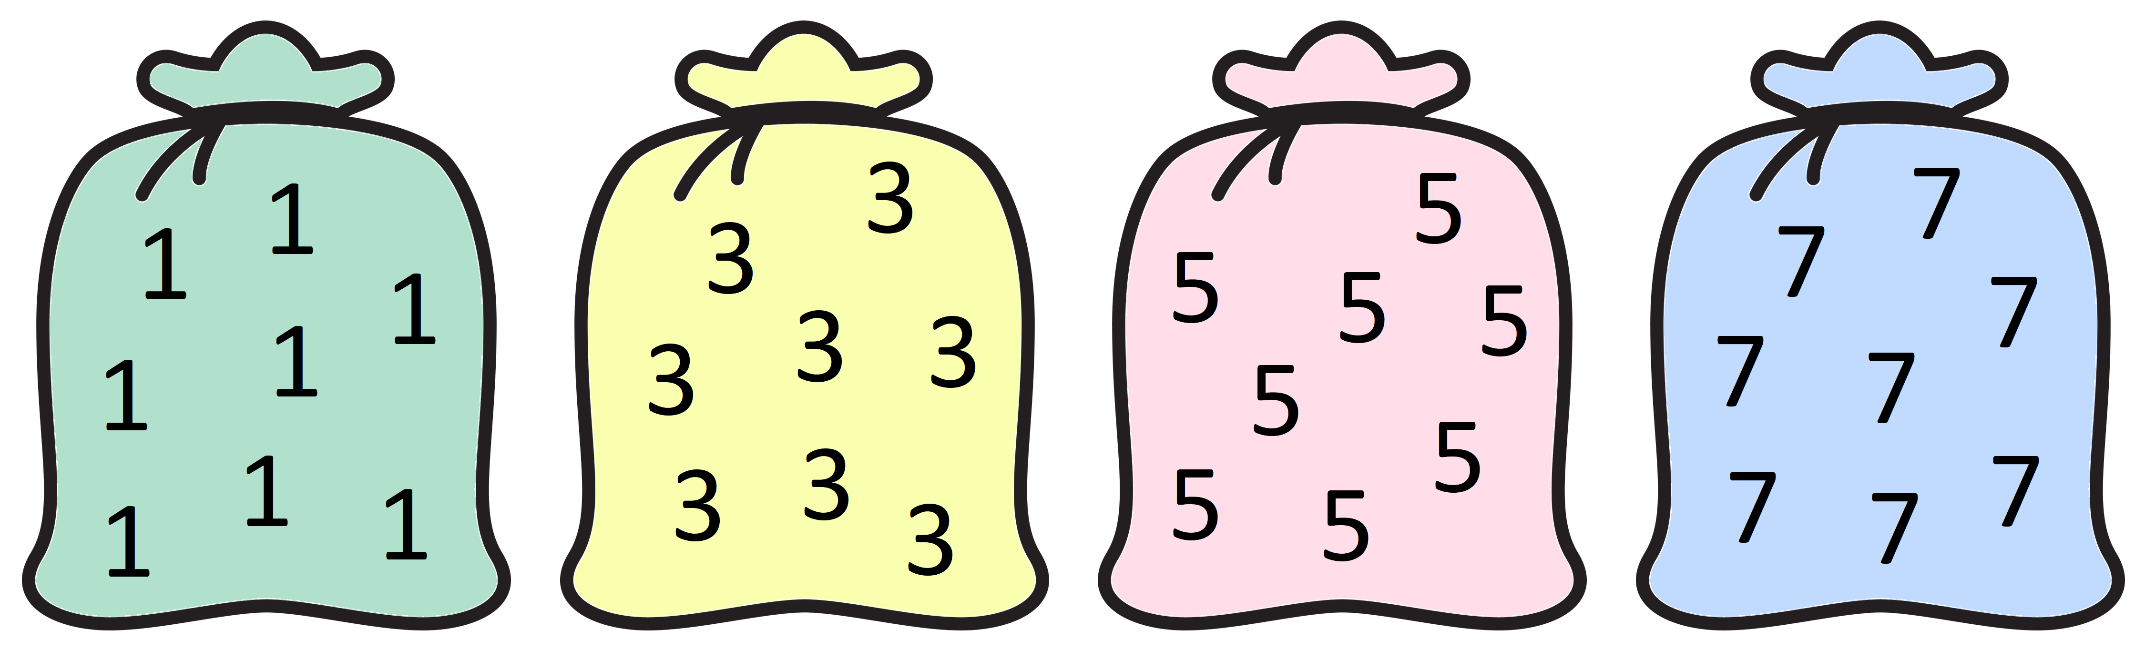

This is a game for two players.
Each bag above has unlimited 1s, 3s, 5s or 7s in it.
Aim of the game:
To be the player to add the final number to the 'running' total to make 37.
How to play:
- Decide who is going first.
- Player 1 chooses one of the numbers from the bags above (1, 3, 5 or 7).
- Player 2 then chooses a number from one of the bags and adds this onto Player 1's number to make a 'running' total.
- Player 1 then has another turn and adds that number onto the 'running' total.
- Play continues like this with each player choosing a number and adding it onto the 'running' total.
Things to think about:
How many numbers did you use altogether in the game?
Have another go. How many numbers did you use this time?
What is the largest number of numbers you could use to reach 37?
What is the smallest number of numbers you could use to reach 37?
Can you use all the different numbers of numbers in between the largest and the smallest to reach 37?
What do you notice? Will your noticing/s always be true? Can you explain why or why not?
Fran says, "I need to go first in order to win."
Do you agree with Fran? Why or why not?

