Wrapping Presents: Solution

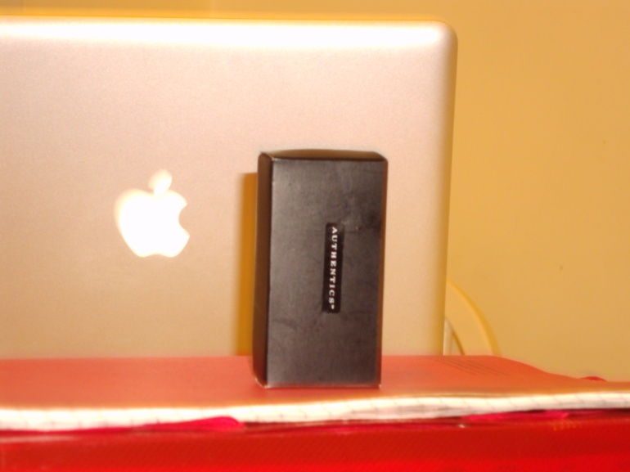
The Box
24.25 cm
8cm
S
S
B
T
S
S

Area: 612.3125 cm²
25.25cm
Perimeter: 98.5 cm

6cm

