Juniper Class, Y3 Orchards Primary School, Wisbech
Live nRich Solution for Four Triangles Puzzle
First, we followed the rules:
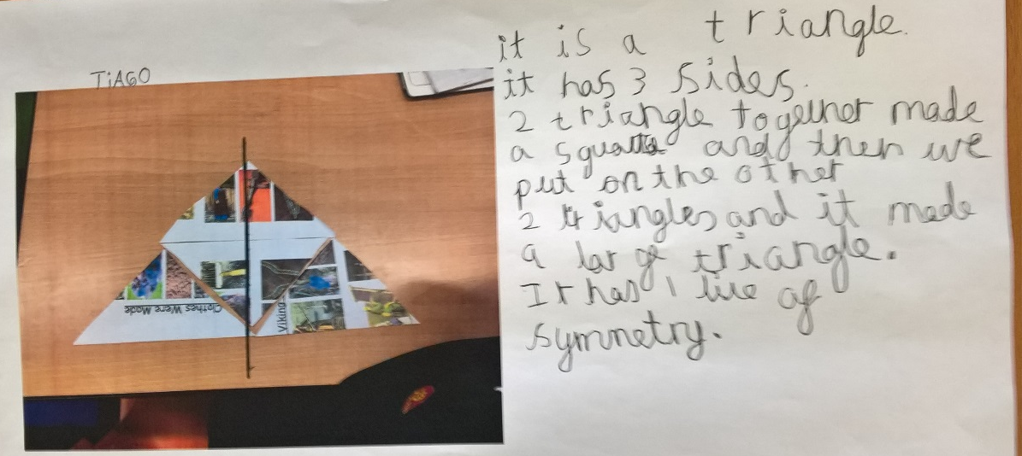
Then, we decided to see what would happen if we could make other shapes that DID NOT have sides that necessarily fitted against one another:
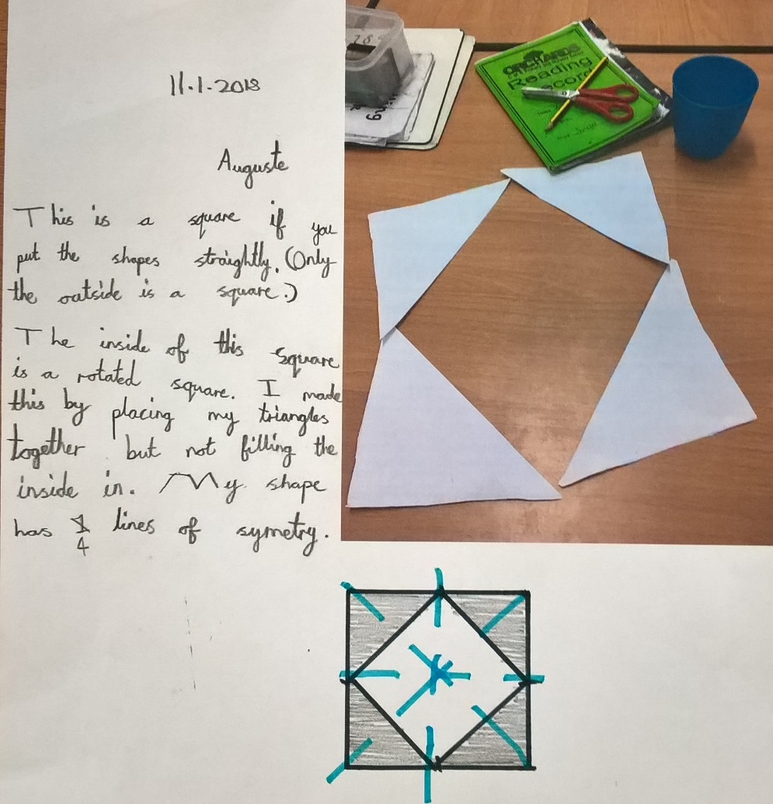
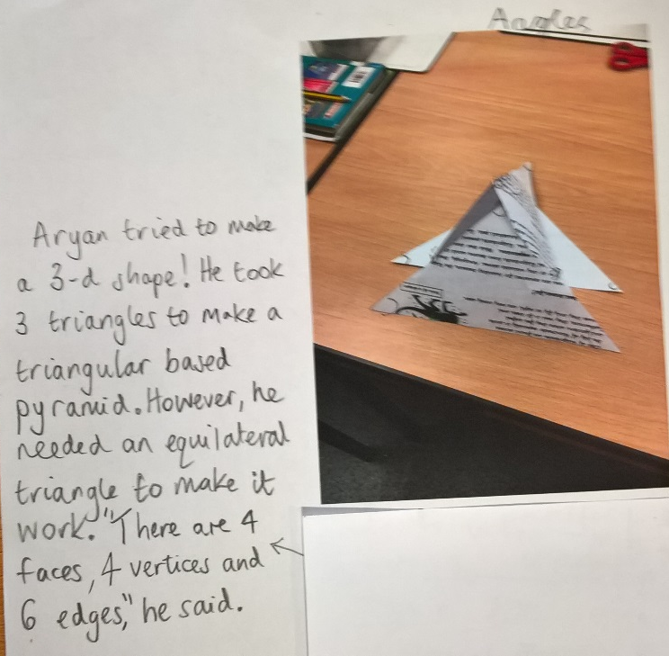

At the same time, lots of Juniper Class wrote everything that they could possibly think of for ONE SHAPE only:
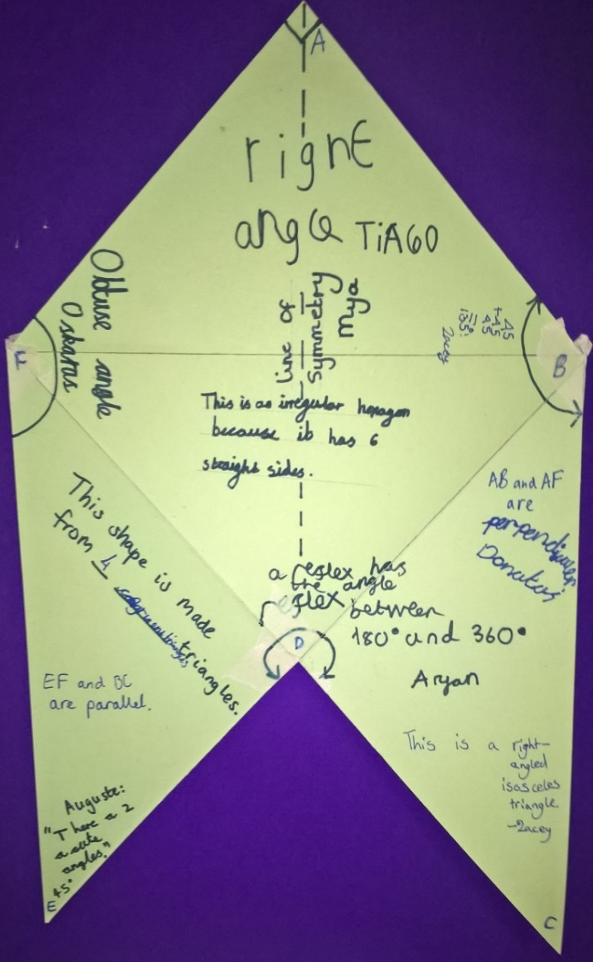
We also agreed that we could NOT possibly make a circle!

