Oscar from Cambridge Regional College is thinking about the strategy for the ‘On-line’ NRICH game

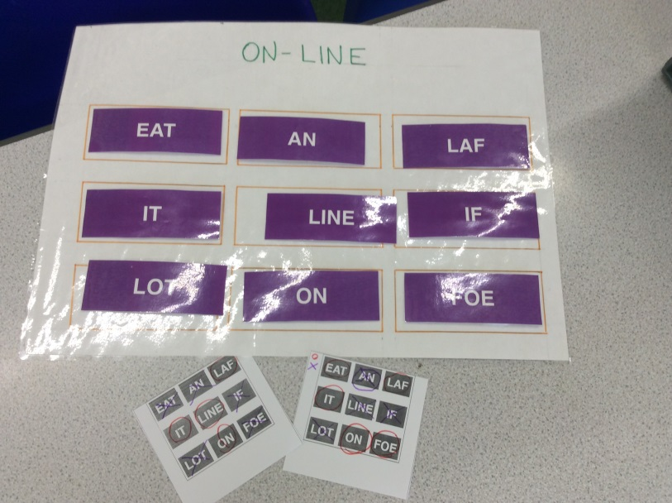
At the beginning I was thinking carefully about combinations of letters and what letter to pick. I thought that the word that has most letters gives you an advantage in the game. Then I realised that blocking the other player reminds me of the knots and crosses game. As the result, I started ignoring the letters and playing this game as knots and crosses.
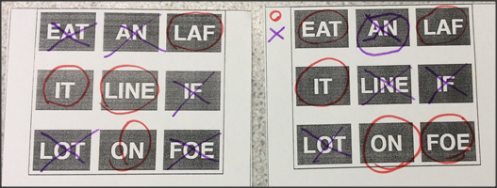
Basically, to find the strategy for this game means to answer how not to lose in a knots and crosses game or not to give a win away to the opponent.
When can I win knots and crosses?
- when the other player is not attentive enough (I assume that all players are attentive)
- when a player carries out a ‘double attack’ – so I need to make sure that I don’t let a double attach happen. But how to do this?

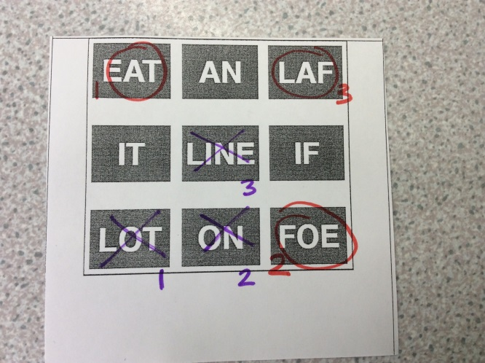

3
1
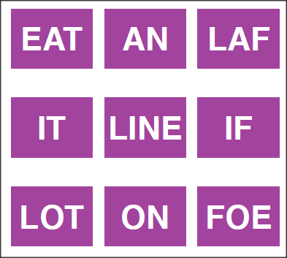
Blue start
Now, the pink can choose AN and IF, therefore, it is ‘a double connection’
2
3
1
2

I have noticed that I need to block as many corners as possible to avoid a double attack from the opponent and thus, not lose.

What about the strategy when I play against the computer?

When I started playing against the computer, I felt that it was harder without a knots and crosses layout, I had to focus back on letters – on what letters the computer has chosen. Then I noticed that all corner words would have three letters. Therefore, instead of picking a corner in knots and crosses, I would pick a letter which has 3 letters.
There are four letters; this means that there are four directions for winning (centre of the square)
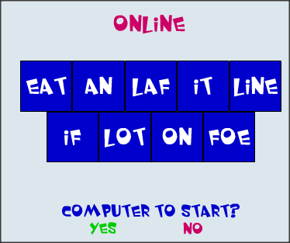
There are two letters; this means that there are two directions for winning (or mid-points)
There are three letters; this means that there are three directions for winning (or corners)

PS this poster was displayed in maths/English staff room with the aim to bring English and maths teams together in discussions and to break a stereotype within the English team about maths as a subject about ‘sums’ alone.

Maria Veselova-Smith

