# Factors and Multiples Puzzle

#### To try this puzzle you will need a copy of the playing board and cards.

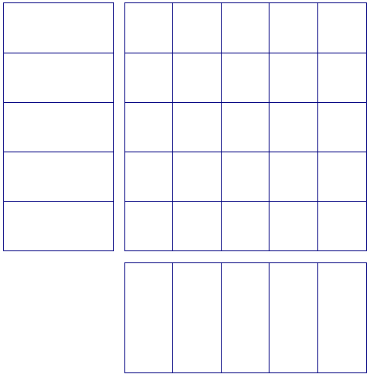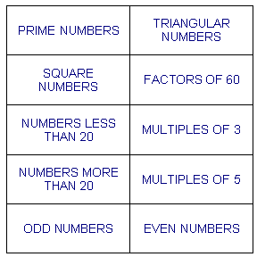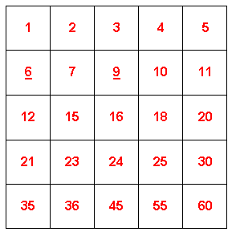

#### Cut out the 10 heading cards and put one in each of the 10 spaces round the playing board.

#### Cut out the 25 number cards and place each one in a different square on the playing board so that the number satisfies the condition given by the heading card for that row and the condition given by the heading card for that column.

#### By rearranging the heading cards and the number cards, try to fill as many squares on the playing board as possible.

#### Can you fill all the squares on the board at once?

### You Will Need:

* Copies of the cards and playing board above are available for printing from the site

### Teachers’ Notes

### Why do this problem?

[This puzzle](http://nrich.maths.org/public/viewer.php?obj_id=5448) provides an interesting context which challenges pupils to apply their knowledge of the properties of numbers. Pupils need to work with various types of numbers at the same time and consider their relationships to each other (e.g. primes, squares and specific sets of multiples).

### Possible approach

Show a 3x3 grid with six headings on the board, ask pupils to suggest numbers that could fit into each of the nine segments (an easy start, but useful revision of vocabulary).

The students (ideally working in twos or threes) can then be set the challenge of filling the 5x5 board with the available numbers.

There isn't a single solution so students could display their different arrangements. When a pupil/pair finishes allocating numbers to a grid, they should record the grid headings and how many numbers they placed.

The current "winning" pupil's name could be on the board as a challenge, to be beaten; or pupils could win points 10,8,6,4,2 for each grid filled with 25,24,23,22,21 numbers respectively.

A concluding plenary could ask pupils to share any insights and strategies that helped them succeed at this task.

### Key questions

Which numbers are hard to place?  
Which intersections are impossible?  
Encourage pupils to pay attention to the order in which they allocate numbers to cells - recognising the key cells to fill, and the key numbers to place.

### Possible extension

Teachers can adapt the task by changing the heading cards or by asking students to create a new set of heading cards and a set of numbers that make it possible to fill the board. Students could then swap their new puzzles.

Is it possible to create a puzzle that can be filled with 25 consecutive numbers?

### Possible support

Some pupils could be given a larger range of numbers to choose from, or offered a smaller grid and appropriately restricted numbers - this could work with pupils choosing from the full set of 10 categories, or with an adapted set.